
BRAIN TUMOUR DETECTION USING DEEP LEARNING

A Project report submitted in partial fulfillment of requirements for the award of degree of

BACHELOR OF TECHNOLOGY IN
COMPUTER SCIENCE AND ENGINEERING
By
Badiginchala Akhila (229X1A0503) Akula Kusumanjali (229X1A0501)

Under the esteemed guidance of

Sri. B. Dilip Kumar Reddy Assistant Professor Department of C.S.E.
Department of Computer Science and Engineering
G. PULLA REDDY ENGINEERING COLLEGE (Autonomous): KURNOOL

(Affiliated to JNTUA, ANANTAPURAMU)
2025 – 2026

Department of Computer Science and Engineering
G. PULLA REDDY ENGINEERING COLLEGE (Autonomous): KURNOOL

(Affiliated to JNTUA, ANANTAPURAMU)

CERTIFICATE
This is to certify that the Project Work entitled ‘Brain Tumour Detection Using Deep Learning’ is a bonafide record of work carried out by

Badiginchala Akhila (229X1A0503) Akula Kusumanjali (229X1A0501)
Under my guidance and supervision in partial fulfillment of the requirements for the award of degree of
BACHELOR OF TECHNOLOGY IN
COMPUTER SCIENCE AND ENGINEERING


……………………………..
Sri. B. Dilip Kumar Reddy Assistant Professor, Department of C.S.E.,
G. Pulla Reddy Engineering College,
Kurnool.
……………………………..
Dr. N. Kasiviswanath
Professor & Head of the Department, Department of C.S.E.,
G. Pulla Reddy Engineering College,
Kurnool.

DECLARATION

We hereby declare that the project titled “BRAIN TUMOUR DETECTION USING DEEP LEARNING” is an authentic work carried out by us as the students of G. PULLA REDDY ENGINEERING COLLEGE(Autonomous) Kurnool, during 2025-26 and has not been submitted elsewhere for the award of any degree or diploma in part or in full to any institute.

Badiginchala Akhila (229X1A0503)

Akula Kusumanjali (229X1A0501)

ACKNOWLEDGEMENT

We wish to express our deep sense of gratitude to our project guide Sri. B. Dilip Kumar Reddy, Assistant Professor of Computer Science and Engineering Department, G. Pulla Reddy Engineering College, for his immaculate guidance, constant encouragement and cooperation which have made possible to bring out this project work.
We are grateful to our project incharge Dr. K. Ishthaq Ahamed, Associate Professor of Computer Science and Engineering Department, G. Pulla Reddy Engineering College, for helping us and giving us the required information needed for our project work.
We are thankful to our Head of the Department Dr. N. Kasiviswanath, for his whole hearted support and encouragement during the project sessions.
We are grateful to our respected Principal Dr. B. Sreenivasa Reddy for providing requisite facilities and helping us in providing such a good environment.
We wish to convey our acknowledgements to all the staff members of the Computer Science and Engineering Department for giving the required information needed for our project work.
Finally, we wish to thank all our friends and well wishers who have helped us directly or indirectly during the course of this project work.

ABSTRACT

Brain tumours are a critical medical condition that require early and accurate diagnosis. Manual analysis of Magnetic Resonance Imaging (MRI) scans by radiologists is often time-consuming and may be subject to human error. This project presents an automated system for brain tumour detection using deep learning techniques to improve the efficiency and reliability of diagnosis. The proposed approach is based on a Convolutional Neural Network (CNN) with transfer learning, utilising the MobileNetV2 architecture as a feature extractor. The model is trained on preprocessed MRI images, which undergo resizing, normalisation, and augmentation to enhance performance and generalisation. The system is capable of classifying MRI images into tumour and non-tumour categories, achieving a validation accuracy of approximately 92%.
In addition to classification, the system incorporates Gradient-weighted Class Activation Mapping (Grad-CAM) to provide visual explanations of the model’s predictions by highlighting the important regions in the MRI scans. This improves the interpretability of the model and makes the system more reliable for practical use. Furthermore, a user-friendly web interface is developed using Streamlit, enabling users to upload MRI images and obtain instant predictions along with visual outputs. The overall system demonstrates the effectiveness of deep learning in medical image analysis and provides a supportive tool for assisting healthcare professionals in brain tumour detection.

CONTENTS

CHAPTER PAGE NO

- INTRODUCTION 1-10
  - Introduction 2
  - Problem Statement 5
  - Existing System 5
    - Limitations 5
  - Proposed System 6
    - Advantages of Proposed System 7
  - Significance And Relevance of Work 7
  - Objectives 8
  - Methodology 8
  - Organization of Report 9
- LITERATURE SURVEY 11-13
  - Brain Tumour Classification Using Deep CNN 12
  - Brain Tumour Detection Using ML Algorithms 12
  - Transfer Learning Using Pre-Trained Models 13
  - GRAD-CAM visual explanation from DNN 13
- SYSTEM SPECIFICATION 14-15
  - Hardware Requirements 15
  - Software Requirements 15
- SYSTEM ANALYSIS 16-47
  - Introduction 17
  - Feasibility Study 18
    - Technical Feasibility 18
    - Operational Feasibility 20
    - Economic Feasibility 21
  - Dataset 22
    - Features of Dataset 23
  - Requirement Specifications 30
    - Functional Requirements 30
    - Non-Functional Requirements 32
    - Performance Requirements 35
    - ML Packages 36
    - ML Libraries 39
  - About the Technology/Software 40
    - Machine Learning and Deep Learning 40
    - Python 42
    - TensorFlow and Keras 43
    - OpenCV 44
    - MobileNetV2 45
    - Grad-CAM 46
    - Visual Studio Code 47
- SYSTEM DESIGN 48-62
  - Module Description 49
  - System Architecture 54
  - Data Flow Diagrams 56
    - Data Flow Diagram Level 0 56
    - Data Flow Diagram Level 1 57
    - Data Flow Diagram Level 2 58
  - UML Diagrams 60
    - Use Case Diagram 60
    - Activity Diagram 61
    - Sequence Diagram 62
- IMPLEMENTATION AND RESULT ANALYSIS 63-73
  - Introduction 64
  - Deep Learning Model 64
    - Convolutional Neural Network 64
    - Transfer Learning 64
    - MobileNetV2 Architecture 65
    - Binary Classification Layer 65
    - Grad-CAM Explainability 65
  - Code for Implementation of Algorithms 66
  - Performance Evaluation of Model 69
  - Why MobileNetV2 Model 71
  - Deployment 71
  - Prediction 73
- TESTING AND VALIDATION 74-82
  - Methods of Testing 75
    - Unit Testing 75
    - Integration Testing 76
    - Functional Testing 76
    - User Acceptance Testing 76
    - System Testing 77
    - Performance Testing 77
  - Test Cases 78
  - Screenshots 80
- CONCLUSION AND FUTURE ENHANCEMENT 83-84
  - Conclusion 84
  - Future Enhancement 84
- REFERENCES 85

LIST OF FIGURES

SI. NO | FIG. NO | NAME | PAGE NO
1 | Fig 4.3 | Sample of Dataset | 22
2 | Fig 4.3.1 | Classification of Features of Dataset | 23
3 | Fig 4.3.2 | Features of Dataset | 29
4 | Fig 4.5.1 | Brain Tumour Detection Using ML & | 41
5 | Fig 4.5.3 | DL  TensorFlow-Keras Architecture | 43
6 | Fig 4.5.4 | Image Preprocessing Pipeline | 44
7 | Fig 4.5.5 | MobileNetV2 Transfer Learning | 45
8 | Fig 4.5.6 | GRAD-CAM Visualization Process | 46
9 | Fig 4.5.7 | VS Code Environment | 47
10 | Fig 5.1.2 | Final Prediction Model | 53
11 | Fig 5.2 | System Architecture | 54
12 | Fig 5.3.1 | DFD Level 0 | 57
13 | Fig 5.3.2 | DFD Level 1 | 57
14 | Fig 5.3.3 | DFD Level 2 | 59
15 | Fig 5.4.1 | Use Case Diagram | 60
16 | Fig 5.4.2 | Activity Diagram | 61
17 | Fig 5.4.3 | Sequence Diagram | 62
18 | Fig 7.3 (c) | URL Enter Page | 81
19 | Fig 7.3 (d) | Output Snapshot 1 | 81
20 | Fig 7.3 (e) | Output Snapshot 2 | 82
21 | Fig 7.3 (f) | Deployment | 82

LIST OF TABLES

SI.NO | FIGNO | NAME | PAGE NO
1 | Table 6.4 | Performance Evaluation | 70
2 | Table 7.1 | Image Upload & Preprocessing Test | 78
3 | Table 7.2 | Prediction Test 1 | 78
4 | Table 7.3 | Prediction Test 2 | 79
5 | Table 7.4 | Prediction Test 3 | 79
6 | Table 7.5 | Prediction Test 4 | 79

INTRODUCTION

INTRODUCTION
  - INTRODUCTION

Brain tumours are among the most critical and life-threatening neurological disorders, requiring early detection and accurate diagnosis to improve patient survival rates. A brain tumour refers to an abnormal growth of cells within the brain, which may be classified as either benign (non-cancerous) or malignant (cancerous). These tumours can significantly disrupt normal brain functions by affecting essential areas responsible for movement, memory, vision, and other cognitive processes. In severe cases, brain tumours can lead to permanent neurological damage or even death. Therefore, timely identification and precise classification of brain tumours are essential for effective treatment planning and improved patient outcomes.

Medical imaging plays a vital role in the diagnosis of brain tumours, with Magnetic Resonance Imaging (MRI) being one of the most widely used techniques. MRI provides high-resolution images of brain tissues, enabling medical professionals to observe structural abnormalities with great detail. Unlike other imaging methods, MRI is particularly effective in visualising soft tissues, making it highly suitable for detecting tumours in the brain. Radiologists analyse these MRI scans to determine the presence, size, location, and type of tumour. However, manual analysis of MRI images is often a complex and time-consuming process, especially when dealing with a large number of patient scans. Additionally, the accuracy of diagnosis largely depends on the expertise and experience of the radiologist, which may lead to variability and the possibility of human error.

In recent years, the rapid advancement of artificial intelligence (AI) has opened new possibilities in the field of medical image analysis. AI-based systems have shown great potential in assisting healthcare professionals by automating complex tasks and improving diagnostic accuracy. Among various AI techniques, deep learning has emerged as a powerful approach for image-based applications. Deep learning models are capable of learning complex patterns directly from data, eliminating the need for manual feature extraction. This makes them highly suitable for analysing medical images, where subtle differences in patterns can indicate the presence of disease.

Convolutional Neural Networks (CNNs) are a class of deep learning models specifically designed for image processing tasks. CNNs consist of multiple layers that automatically extract hierarchical features from images, such as edges, textures, and shapes. These features are then used to classify the images into different categories. Due to their ability to capture spatial information effectively, CNNs have been widely adopted in medical imaging applications, including tumour detection, disease classification, and organ segmentation. Their performance has been proven to be highly accurate when trained on sufficiently large and well-processed datasets.

In this project, an automated brain tumour detection system is developed using deep learning techniques. The system aims to classify MRI images into two categories: tumour and non-tumour. Instead of building a CNN model from scratch, which requires a large dataset and extensive computational resources, this work utilises transfer learning. Transfer learning is a technique where a pre-trained model is adapted for a new but related task. In this case, the MobileNetV2 architecture is used as the base model. MobileNetV2 is a lightweight and efficient CNN model that has been pre-trained on a large-scale dataset (ImageNet), enabling it to learn rich and generalised image features.

The use of MobileNetV2 offers several advantages, including reduced training time, lower computational requirements, and improved performance, especially when working with limited datasets. In this system, the pre-trained layers of MobileNetV2 are used as a feature extractor, and additional custom layers are added on top of it to perform classification. These layers include Global Average Pooling, Dense layers with activation functions, and Dropout layers to prevent overfitting. By freezing the weights of the base model, the system retains the learned features while adapting to the specific task of brain tumour detection.

Data preprocessing is another crucial step in the development of the system. The MRI images are resized to a fixed dimension to ensure uniformity in input size. Pixel values are normalised to a standard range to improve numerical stability during training. Additionally, data augmentation techniques such as rotation, flipping, and zooming are applied to artificially increase the size of the dataset. This helps in improving the generalisation ability of the model and reduces the chances of overfitting, thereby enhancing overall performance.

The trained model is evaluated using performance metrics such as accuracy, which indicates the proportion of correctly classified images. In this project, the model achieves a validation accuracy of approximately 92%, demonstrating its effectiveness in distinguishing between tumour and non-tumour MRI scans. However, in medical applications, accuracy alone is not sufficient; interpretability of the model is equally important to ensure trust and reliability.

To address this aspect, the system incorporates Gradient-weighted Class Activation Mapping (Grad-CAM), a technique used to provide visual explanations for deep learning models. Grad-CAM generates heatmaps that highlight the regions of the input image that contribute most to the model’s prediction. In the context of brain tumour detection, this allows users to visually understand which part of the MRI scan influenced the decision, thereby increasing transparency and aiding medical professionals in verifying the results.

Furthermore, to enhance usability and accessibility, a web-based interface is developed using Streamlit. This interface allows users to upload MRI images and obtain instant predictions along with Grad-CAM visualisations. The application is designed to be simple and interactive, enabling even non-technical users to operate the system. Additionally, the project is deployed online, making it accessible from any location, which further increases its practical applicability.

In conclusion, this project demonstrates the successful integration of deep learning techniques with medical image analysis to develop an automated brain tumour detection system. By leveraging the power of MobileNetV2, incorporating interpretability through Grad-CAM, and providing a user-friendly interface via Streamlit, the system offers an efficient, accurate, and scalable solution. It has the potential to assist healthcare professionals in early diagnosis, reduce workload, and improve the overall quality of medical decision- making.

PROBLEM STATEMENT

- Manual analysis of brain MRI images for tumour detection is a time-consuming and complex process that depends heavily on the expertise of radiologists. This may lead to inconsistencies, delayed diagnosis, and possible human errors, especially when handling a large number of cases.
- There is a need for an automated and efficient system that can accurately classify MRI images as tumour or non-tumour while also providing visual explanations for its predictions. Existing systems often lack interpretability and real-time accessibility, making them less effective for practical use.

EXISTING SYSTEM

The existing system for brain tumour detection primarily relies on manual analysis of MRI scans by radiologists and medical experts. In this approach, specialists visually examine the MRI images to identify abnormal growths in the brain. Although this method is widely used, it requires significant expertise and experience, and the accuracy depends on the skill of the medical professional.

Traditional computer-aided detection systems are also available, but many of them are based on basic image processing techniques and conventional machine learning algorithms. These methods often require manual feature extraction and may not provide high accuracy when dealing with complex medical images like MRI scans.

Moreover, most existing systems lack automation, real-time prediction capability, and interpretability. They do not provide clear visual explanations of how the decision is made, making it difficult for users to fully trust the output. Additionally, these systems are not easily accessible to general users and are mostly confined to clinical environments.

LIMITATIONS

Time-Consuming Process: Manual analysis of MRI scans by radiologists requires significant time, especially when handling large volumes of data.

Dependency on Expertise: The accuracy of tumour detection heavily depends on the experience and skill of medical professionals, which may vary.

Lower Accuracy in Traditional Methods: Conventional image processing and machine learning techniques may fail to capture complex patterns in MRI images, leading to reduced accuracy.

Lack of Automation: Existing systems do not provide a fully automated solution for tumour detection and require human intervention at multiple stages.

No Visual Explanation: Most systems do not offer interpretability (like heatmaps), making it difficult to understand how the prediction is made.

Limited Accessibility: Many existing tools are confined to clinical environments and are not easily accessible to general users.

PROPOSED SYSTEM

The proposed system aims to develop an automated and efficient brain tumour detection system using deep learning techniques. The system utilises a Convolutional Neural Network (CNN) with a pre-trained MobileNetV2 architecture to analyse MRI scan images and accurately classify them as tumour or non-tumour.

In this approach, the input MRI images are first preprocessed by resizing and normalising them. These images are then passed through the MobileNetV2 model, which is used as a feature extractor. The base model is pre-trained on the ImageNet dataset, allowing it to capture complex image features effectively. Additional custom layers such as Global Average Pooling, Dense layers, and Dropout are added on top of the base model to perform the final classification. The system is trained using labelled MRI datasets, where it learns to distinguish between tumour and non-tumour images. After training, the model is capable of predicting the presence of a tumour in new, unseen MRI scans with high accuracy.

To enhance interpretability, the system incorporates Grad-CAM (Gradient-weighted Class Activation Mapping), which generates heatmaps highlighting the regions of the MRI image that contributed most to the prediction. This helps in understanding the model’s decision-making process.

Additionally, a simple and user-friendly interface is developed using Streamlit, allowing users to upload MRI images and instantly receive predictions along with visual explanations. The final system is deployed online, making it accessible for real-time usage.

    - ADVANTAGES
The major advantages of this project are:

      - High Accuracy: The use of deep learning with MobileNetV2 improves the accuracy of tumour detection compared to traditional methods.
      - Automation: The system provides a fully automated solution for detecting brain tumours from MRI images without manual intervention.
      - Faster Diagnosis: The model processes and predicts results quickly, reducing the time required for analysis.
      - Feature Extraction Capability: MobileNetV2 efficiently extracts complex features from MRI images, improving classification performance.
      - Visual Interpretability: Integration of Grad-CAM provides heatmaps, helping users understand which regions influenced the prediction.
      - User-Friendly Interface: The Streamlit-based web application allows users to easily upload images and get instant results.
      - Accessibility: The deployed system can be accessed online, making it convenient for real-time usage.

SIGNIFICANCE AND RELEVANCE OF WORK
The proposed Brain Tumour Detection system holds significant importance in the field of medical image analysis, as it provides an efficient and automated approach for identifying tumours from MRI scans. Early and accurate detection of brain tumours is crucial for effective treatment planning and improving patient outcomes. By leveraging deep learning techniques such as Convolutional Neural Networks (CNN) and MobileNetV2, the system enhances diagnostic accuracy while reducing the dependency on manual analysis.

This work is highly relevant in today’s context, where there is an increasing demand for intelligent healthcare solutions that can assist medical professionals. The integration of Grad- CAM adds an additional layer of transparency by visually explaining the model’s predictions, which is essential for building trust in AI-based systems. Furthermore, the development of a

user-friendly web interface using Streamlit and its deployment on an online platform makes the solution accessible and practical for real-time use.

Overall, the project contributes towards bridging the gap between advanced deep learning technologies and real-world medical applications, making tumour detection faster, more reliable, and easier to interpret.

OBJECTIVES

- To develop an automated system for detecting brain tumours from MRI images using deep learning techniques.
- To implement a Convolutional Neural Network (CNN) with MobileNetV2 architecture for accurate image classification.
- To preprocess MRI images through resizing and normalisation for effective model training and prediction.
- To train and evaluate the model using labelled datasets to achieve high accuracy in tumour detection.
- To provide prediction results indicating the presence or absence of a tumour along with confidence values.
- To incorporate Grad-CAM for visualising important regions in MRI images and improving model interpretability.
- To develop a user-friendly interface using Streamlit for easy image upload and real- time prediction.
- To deploy the system online so that it can be accessed easily for practical use.

METHODOLOGY

The proposed system follows a structured methodology to detect brain tumours from MRI images using deep learning techniques. Initially, the dataset containing MRI brain images is collected and organised into two categories: tumour and non-tumour. These images are then preprocessed by resizing them to a fixed dimension and normalising pixel values to improve model performance.

Next, a Convolutional Neural Network (CNN) model is developed using the pre-trained MobileNetV2 architecture. The base model is used for feature extraction, and its layers are

frozen to retain learned features. Custom layers such as Global Average Pooling, Dense layers, and Dropout are added to perform classification. The model is then trained using the prepared dataset, and its performance is evaluated using validation data.

Once the model is trained, it is used for prediction, where new MRI images are provided as input to classify whether a tumour is present or not. To enhance the interpretability of the model, Grad-CAM is applied to generate heatmaps that highlight the important regions influencing the prediction.

Finally, the system is integrated into a Streamlit-based web application, allowing users to upload MRI images and obtain predictions along with visual explanations. The complete application is deployed online, enabling real-time access and usability.

ORGANIZATION OF THE REPORT

Chapter 1 Overview:
The overview provides the basic layout and insight about the proposed work. It describes the need for developing an automated system for brain tumour detection using deep learning techniques.

Problem Statement:
This section defines the problem of manual and time-consuming tumour detection from MRI images and the need for an efficient automated solution.

Significance and Relevance of Work:
This section highlights the importance of the system in assisting medical diagnosis and improving accuracy using advanced deep learning models.

Objectives:
This section describes the main goals of the project, including model development, prediction, and deployment.

Methodology:
This section explains the step-by-step procedure followed in developing the system, including data preprocessing, model building using MobileNetV2, and prediction.

Chapter 2 Literature Survey:
This section provides a detailed study of existing research papers and techniques related to brain tumour detection using machine learning and deep learning approaches.

Chapter 3 SystemRequirements:
This section includes the hardware and software requirements necessary to implement the proposed system.

Chapter 4 SystemAnalysis:
This section describes the existing and proposed systems along with their advantages and limitations.

Chapter 5 SystemDesign:
This section explains the architecture of the system, including data flow diagrams, model structure, and overall design.

Chapter 6 Implementation:
This section provides detailed information about the implementation of the project, including algorithms, model training, and code execution.

Chapter 7 Testing:
This section describes different testing methods such as unit testing, validation testing, and functional testing.

Chapter 8
Results and Analysis:
This section presents the output of the system along with performance metrics like accuracy, precision, recall, and F1-score.

Chapter 9
Conclusion and Future Enhancement:
This section summarises the overall work and suggests possible improvements and future scope of the project

LITERATURE SURVEY

LITERATURE SURVEY

  - Brain Tumor Classification Using Deep Convolutional Neural Networks Authors: Afshar, P., Plataniotis, K. N., & Mohammadi, A. (2019)
This paper proposes a deep learning approach for brain tumour classification using Convolutional Neural Networks (CNN). The model is designed to automatically extract spatial and hierarchical features from MRI images, eliminating the need for manual feature engineering. The architecture consists of multiple convolutional and pooling layers followed by fully connected layers for classification. The study demonstrates that CNN-based models significantly improve classification accuracy compared to traditional methods. However, the performance of the model depends heavily on the availability of a large and well-labelled dataset, and training such deep networks requires high computational resources.
Remarks: This paper highlights the effectiveness of CNN in medical image classification and forms the foundation for using deep learning in the proposed system.

  - Brain Tumor Detection Using Machine Learning Algorithms Authors: Kaur T., & Gandhi, T. K. (2019)
This study presents a machine learning-based approach for detecting brain tumours from
MRI images. The methodology includes preprocessing steps such as noise removal and image enhancement, followed by segmentation to isolate the tumour region. Feature extraction techniques are then applied, and classifiers like Support Vector Machine (SVM) and K-Nearest Neighbour (KNN) are used for classification. Although the system achieves moderate accuracy, it relies heavily on handcrafted features and manual intervention, which limits its scalability and performance on complex datasets.
Remarks: This paper shows the limitations of traditional machine learning approaches and justifies the need for automated feature extraction using deep learning models.

  - Transfer Learning for Medical Image Classification Using Pre-Trained Models Authors: Shin, H. C., Roth, H. R., Gao M. (2016)
This paper explores the application of transfer learning in medical image analysis using pre-trained deep learning models such as VGG16 and ResNet. The key idea is to utilise knowledge gained from large-scale datasets like ImageNet and apply it to medical imaging tasks. This approach reduces training time and improves classification performance, especially when the available dataset is limited. However, the models used are computationally expensive and may not be suitable for real-time or resource-constrained environments..
Remarks: This work supports the use of transfer learning in the proposed system and motivates the selection of MobileNetV2 as a more efficient alternative.

Grad-CAM: Visual Explanations from Deep Networks via Gradient-Based Localization
Authors: Selvaraju, R. R., Cogswell, M., Das, A.. (2017)
This paper introduces Gradient-weighted Class Activation Mapping (Grad-CAM), a technique used to provide visual explanations for predictions made by deep learning models. Grad-CAM generates heatmaps that highlight important regions in an image that influence the model’s decision. This improves transparency and interpretability, especially in sensitive domains such as healthcare. However, Grad-CAM does not perform classification independently and is used as a supplementary tool for visualisation.
Remarks: This paper plays a crucial role in enhancing the interpretability of the proposed system by allowing visual analysis of tumour regions.

SYSTEM SPECIFICATIONS

SYSTEM REQUIREMENTS AND SPECIFICATION
System Requirements specify the essential resources required for the development and execution of the proposed Brain Tumour Detection System. These requirements ensure that the system functions efficiently during model training, prediction, and deployment.

HARDWARE REQUIREMENTS

Hardware requirements refer to the essential physical components and specifications necessary for the proper functioning of the proposed system. These include the processing capability of the CPU, available memory, and storage capacity required to handle image data and execute deep learning models efficiently. Proper hardware configuration ensures smooth training, testing, and deployment of the application without performance issues.
- Operating System : Microsoft- Windows 10/8/7
- Hard Disk : Minimum 256 GB
- Ram : 8 GB.
- Processor : Minimum Core i5
- Any desktop / Laptop system with above configuration or higher level

SOFTWARE REQUIREMENTS

Software requirements encompass the essential tools and technologies required for the development, implementation, and execution of the system. These include the programming language, development environment, and libraries used for building the deep learning model and processing MRI images. The selected software tools provide a reliable and efficient environment for developing and deploying the application.
- Operating system: Windows 10
- Coding Language: Python
- Version: Python 3.x
- IDE: Visual Studio Code
- Deep Learning Framework: TensorFlow, Keras
- Libraries Used: NumPy, OpenCV, Matplotlib.
- Web Framework: Streamlit
- Model Format: .h5 (Trained Model File)

SYSTEM ANALYSIS

SYSTEM ANALYSIS

INTRODUCTION

System Analysis forms the backbone of any successful software development process, as it provides a clear understanding of the problem domain and lays the foundation for an effective solution. It involves a detailed examination of existing methodologies, identification of their limitations, and formulation of a structured approach to overcome those challenges. A well-defined system analysis ensures that the proposed system is not only technically sound but also practical and efficient in real-world scenarios.

In the domain of medical imaging, particularly brain tumour detection, accurate analysis of MRI scans plays a critical role in early diagnosis and treatment planning. Traditional approaches rely heavily on manual interpretation by radiologists, which, although reliable, can be time-intensive and prone to variability depending on expertise and workload. Furthermore, earlier computational techniques based on conventional machine learning require manual feature extraction, making them less effective in capturing complex patterns present in medical images.

To address these challenges, the proposed system adopts a deep learning-based approach that enhances both accuracy and efficiency. By leveraging the power of Convolutional Neural Networks (CNN) with the MobileNetV2 architecture, the system is capable of automatically learning meaningful features from MRI images. In addition to classification, the integration of Grad-CAM provides visual insights into the model’s decision-making process, thereby improving transparency and trust in the system.

This chapter presents a comprehensive analysis of the proposed system, including feasibility evaluation, dataset characteristics, requirement specifications, and the technologies employed. It establishes a strong foundation for understanding how the system is designed to deliver accurate, efficient, and interpretable results in brain tumour detection.

FEASIBILITY STUDY

Feasibility Study is an essential step in system analysis that evaluates the practicality and viability of the proposed system before its full-scale implementation. It helps in determining whether the system can be developed and deployed successfully within the available resources, time, and technological constraints. By analysing different aspects such as technical capability, operational usability, and economic cost, feasibility study ensures that the proposed solution is both realistic and effective.

In the context of the Brain Tumour Detection System, the feasibility study plays a significant role in validating the use of deep learning techniques for medical image analysis. The proposed system utilises modern technologies such as Python, TensorFlow, and the MobileNetV2 architecture, which are widely accepted and proven to be efficient for image classification tasks. Additionally, the use of Grad-CAM enhances the system by providing visual explanations, making it more reliable and interpretable.

The feasibility of the system is analysed under three major categories: technical feasibility, which examines the technological requirements and implementation capability; operational feasibility, which focuses on user interaction and system usability; and economic feasibility, which evaluates the cost-effectiveness of the system. Together, these aspects provide a comprehensive understanding of the system’s practicality and ensure its successful deployment.

TECHNICAL FEASIBILITY

Technical feasibility refers to the assessment of whether the proposed system can be effectively developed and implemented using the available technologies, tools, and computational resources. It ensures that the system design is practical and that all technical requirements can be satisfied without the need for specialised or unavailable infrastructure.

In the proposed Brain Tumour Detection System, the implementation is carried out using Python, which is widely recognised for its simplicity, flexibility, and extensive support for machine learning and deep learning applications. Python provides a rich ecosystem of libraries and frameworks that simplify the development of complex models. In this project, deep learning frameworks such as TensorFlow and Keras are used to design, train, and evaluate the Convolutional Neural Network model.

A key technical aspect of the system is the use of the MobileNetV2 architecture, which is a pre-trained deep learning model known for its efficiency and performance. Unlike traditional deep learning models that require extensive computational power, MobileNetV2 is specifically designed to be lightweight while maintaining high accuracy. This makes it particularly suitable for systems with limited computational resources. By leveraging transfer learning, the model utilises pre-trained weights and adapts them to the brain tumour classification task, thereby reducing training time and improving performance.

The system processes MRI images by applying essential preprocessing steps such as resizing the images to a fixed dimension (150 × 150 pixels) and normalising pixel values. These operations ensure consistency in input data and improve the model’s ability to learn meaningful patterns. Libraries such as NumPy and OpenCV are used for efficient numerical computation and image processing, enabling smooth handling of large datasets.

Another important technical component of the system is the implementation of Grad- CAM (Gradient-weighted Class Activation Mapping). This technique enhances the functionality of the system by generating heatmaps that visually highlight the regions of the MRI image that contribute most to the model’s prediction. The inclusion of Grad-CAM not only strengthens the system’s analytical capability but also improves transparency, which is a critical requirement in medical applications.

The model is trained and evaluated using the available hardware configuration, which includes a standard CPU-based system without the need for a dedicated GPU. Despite this limitation, the system achieves satisfactory performance, demonstrating that the chosen technologies are efficient and well-optimised. The trained model is stored in a .h5 format, allowing it to be easily loaded for prediction and deployment.

In addition to model development, the system is integrated with a simple user interface using Streamlit, which enables real-time interaction. This further proves that the overall system can be implemented using readily available tools without requiring complex infrastructure.

OPERATIONAL FEASIBILITY

Operational feasibility evaluates how effectively the proposed system can be used in a real-world environment. It focuses on the ease of use, user interaction, system accessibility, and the overall ability of the system to function as intended without causing complexity for the end user. A system is considered operationally feasible if it is user-friendly, reliable, and capable of delivering results efficiently.

In the case of the proposed Brain Tumour Detection System, operational feasibility is achieved through the development of a simple and interactive user interface using Streamlit, a lightweight web application framework. The interface is designed to allow users to easily interact with the system without requiring any prior technical knowledge. Users can upload MRI images directly through the interface, making the system highly accessible and convenient to use.

The workflow of the system is designed to be straightforward and intuitive. Once the user uploads an MRI image, the system automatically performs preprocessing steps such as resizing and normalisation in the background. The processed image is then passed to the trained MobileNetV2 model, which generates a prediction indicating whether a tumour is present or not. The result is displayed clearly on the interface along with the prediction confidence, ensuring that the output is easy to understand.

An important feature that enhances operational usability is the integration of Grad-CAM visualisation. The system generates heatmaps that highlight the regions of the MRI image influencing the model’s decision. This visual feedback helps users interpret the results more effectively, especially in medical contexts where understanding the reasoning behind predictions is crucial.

The system is designed to provide results within a short period of time, ensuring a smooth user experience. Since the model is lightweight and optimised, predictions are generated quickly even on systems without high-end hardware. This makes the system suitable for practical usage in environments where computational resources may be limited.

Furthermore, the system does not require complex installation or configuration. Once deployed (for example, using platforms like Render or locally via Streamlit), it can be accessed through a web browser. This eliminates the need for specialised software and makes the system widely accessible.

In conclusion, the proposed system is operationally feasible as it provides a user-friendly, efficient, and accessible solution for brain tumour detection. The integration of an interactive interface along with accurate prediction and visual explanation ensures that the system can be effectively used in real-world scenarios.

ECONOMIC FEASIBILITY

Economic feasibility evaluates the cost-effectiveness of the proposed system by analysing the financial resources required for its development, implementation, and maintenance. It ensures that the system can be developed within a reasonable budget while delivering significant value and benefits.

In the proposed Brain Tumour Detection System, the overall development cost is minimal, as the project primarily utilises open-source technologies and tools. The programming language Python, along with libraries such as TensorFlow, Keras, NumPy, OpenCV, and Matplotlib, are freely available and widely supported. This eliminates the need for purchasing expensive software licenses or proprietary tools.

The development environment used for the project, such as Visual Studio Code, is also freely available, further reducing the cost involved in system development. Additionally, the model is trained using a standard CPU-based system without requiring specialised hardware such as high-end GPUs. This makes the system economically viable even for users or organisations with limited resources.

The deployment of the system using platforms like Render or running it locally through Streamlit does not involve significant financial investment. Basic deployment options are available at low or no cost, making the system accessible for demonstration and practical use.

Moreover, the system contributes to reducing indirect costs associated with manual diagnosis, such as time consumption and dependency on continuous human analysis.

By automating the detection process, the system has the potential to improve efficiency and reduce workload, which can be beneficial in real-world scenarios.

In conclusion, the proposed system is economically feasible as it is developed using cost- effective tools, requires minimal resources, and provides valuable outcomes without incurring significant expenses. This makes it a practical and affordable solution for brain tumour detection.

DATASET
The dataset plays a crucial role in the development and performance of the proposed Brain Tumour Detection System. It provides the necessary input data for training and evaluating the deep learning model. In this project, a dataset consisting of MRI (Magnetic Resonance Imaging) brain images is used to classify whether a tumour is present or not.
The dataset is organised into two main categories: Tumour and No Tumour, making it suitable for binary classification. These images represent different conditions of the brain, allowing the model to learn distinguishing features between normal and abnormal cases. The dataset is divided into training and validation sets, which helps in evaluating the performance of the model on unseen data.
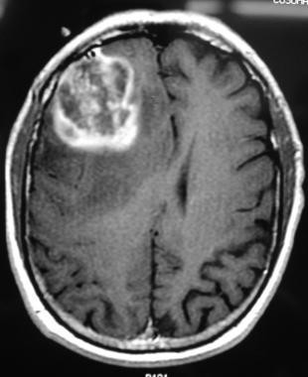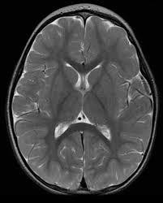
Fig 4.3 Sample of dataset

Before feeding the images into the model, several preprocessing steps are applied to ensure consistency and improve model accuracy. All images are resized to a fixed dimension of 150 × 150 pixels, which matches the input requirements of the MobileNetV2 model. Additionally, pixel values are normalised to bring them into a standard range, which helps in faster convergence during training.

The dataset is loaded using image data generators, which also allow efficient handling of large image data during training. This structured approach ensures that the model learns effectively from the dataset and generalises well to new inputs.
The quality, diversity, and proper preprocessing of the dataset significantly influence the performance of the system. A well-prepared dataset enables the model to achieve higher accuracy and reliable predictions.

FEATURES OF DATASET

The dataset used in the proposed Brain Tumour Detection System comprises several important characteristics that must be carefully analysed to effectively identify and classify MRI brain images. In medical image analysis, these features are crucial as they capture variations in brain structure, intensity patterns, and image quality, which directly influence the performance of the deep learning model.
        - Structural and Anatomical Features
        - Intensity and Texture-Based Features
        - Class Representation Features
        - Preprocessing and Input Standardisation Features
        - Variability and Robustness Features
        - Computational and Organisational Features
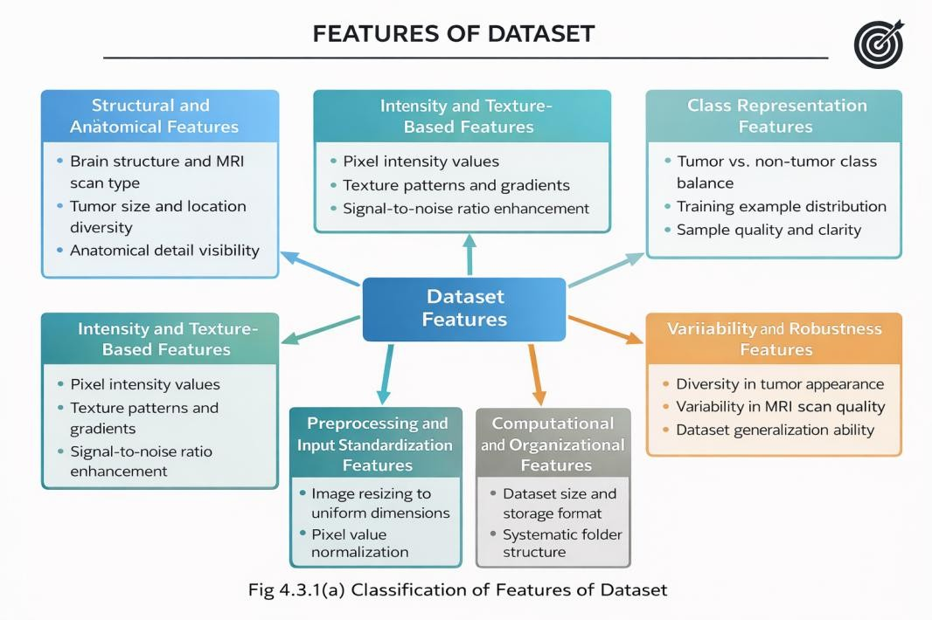

Fig 4.3.1 Classification of Features of Dataset

Structural and Anatomical Features
Structural and anatomical features are the most important characteristics present in brain MRI images because they represent the physical arrangement of brain tissues and help in identifying abnormal growth patterns. In the proposed Brain Tumour Detection System, these features are used to observe the shape, position, and structure of different regions of the brain.
Normally, the human brain has a symmetrical appearance in MRI scans, where the left and right hemispheres appear balanced. However, when a tumour is present, this symmetry may be disturbed due to abnormal tissue growth. Tumours may compress nearby tissues, shift brain structures from their original position, or create unusual masses in specific regions of the brain. These abnormalities become important visual indicators for the deep learning model.
The MRI images in the dataset contain tumours of different sizes and shapes. Some tumours appear as small, localized masses, while others spread over a larger region of the brain. Similarly, the location of the tumour also varies from one image to another. Certain tumours may occur in the frontal lobe, while others may appear in the temporal, parietal, or occipital regions. Because of this diversity, the model is exposed to multiple structural variations during training, which improves its ability to recognize tumours in unseen images.
Another important anatomical feature is the visibility of brain boundaries and internal tissue patterns. MRI scans provide clear differentiation between soft tissues, allowing the model to identify the difference between healthy tissue and tumour-affected regions. By learning these anatomical patterns, the deep learning model becomes capable of distinguishing normal brain structure from abnormal growth more accurately.
Thus, structural and anatomical features form the foundation of the dataset, as they provide the primary information required for tumour detection and classification.

Intensity and Texture-Based Features
Intensity and texture-based features are important image characteristics that help the model identify subtle differences between normal brain tissues and tumour-affected regions. In MRI scans, different tissues produce different intensity values based on how they respond to the imaging process. As a result, tumour regions often appear brighter or darker than the surrounding healthy tissues.

The intensity of a pixel refers to its brightness value in the image. Healthy brain tissues generally have a consistent intensity distribution, whereas tumour regions may contain irregular intensity variations due to the presence of abnormal cells, swelling, or fluid accumulation. These changes in pixel intensity allow the model to detect suspicious areas that may indicate the presence of a tumour.
Texture features describe the surface pattern or appearance of different regions in the MRI image. Healthy tissues usually have smooth and uniform textures, while tumour regions may appear rough, uneven, or highly irregular. Some tumours have clearly defined boundaries, whereas others blend gradually into nearby tissues. Because of this, the texture around a tumour region may differ significantly from the surrounding normal brain structure.
The deep learning model learns these intensity and texture variations automatically during training. Convolutional layers in the model identify patterns such as edges, gradients, contrast differences, and irregular pixel arrangements. These learned features help the model distinguish tumour regions from non-tumour regions more accurately.
In the proposed system, preprocessing techniques such as normalization are applied to standardize the intensity values across all MRI images. This ensures that differences in brightness caused by varying scan conditions do not affect the performance of the model. As a result, the system becomes more reliable in identifying tumour-related intensity and texture patterns.

Class Representation Features
Class representation features describe how the MRI images are distributed among the different classes in the dataset. In the proposed Brain Tumour Detection System, the dataset is divided into two main categories: tumour images and non-tumour images. Since the project is designed as a binary classification problem, these two classes are sufficient for training the model.
The tumour class contains MRI images in which abnormal tissue growth is present within the brain. These images may show tumours of different sizes, shapes, and locations. On the other hand, the non-tumour class contains MRI scans of healthy brains where no tumour is present. The presence of both categories allows the model to learn the difference between normal and abnormal brain structures.

Proper class representation is important because the performance of the model depends heavily on how balanced the dataset is. If the dataset contains too many tumour images and very few non-tumour images, the model may become biased toward predicting only the tumour class. Similarly, if there are too many non-tumour images, the model may fail to identify tumour cases correctly.
To avoid this issue, the dataset should contain a reasonable number of examples from both classes. Balanced representation helps the model learn equally from tumour and non- tumour images, which improves prediction accuracy and reduces classification errors.
The organization of the dataset into separate folders for each class also simplifies the training process. Deep learning libraries such as TensorFlow and Keras can easily read images from these folders and assign the correct labels automatically. This organized structure supports efficient training, validation, and testing of the model.
Therefore, class representation features play an important role in ensuring that the model learns effectively and provides accurate results for both tumour and non-tumour MRI images.

Preprocessing and Input Standardisation Features
Preprocessing and input standardisation features are essential steps performed before training the deep learning model. Since MRI images in the dataset may differ in size, brightness, orientation, and quality, preprocessing is required to convert them into a consistent format that can be easily understood by the model.
One of the main preprocessing steps used in this project is image resizing. MRI images are originally available in different dimensions, but deep learning models require all input images to have the same size. Therefore, each image is resized to a fixed dimension before being passed to the model. This ensures uniformity and allows the model to process all images efficiently.
Another important preprocessing step is normalization. MRI images contain pixel values that usually range from 0 to 255. These values are scaled to a smaller range, typically between 0 and 1, by dividing each pixel value by 255. Normalization helps the model train faster because it reduces large variations in pixel intensity values. It also improves the stability of the training process and prevents the model from becoming biased toward certain images.

In this project, preprocessing is especially important because the system uses transfer learning with MobileNetV2. This pretrained model expects input images in a specific format and size. Therefore, standardizing the dataset ensures compatibility with the model architecture and improves feature extraction performance.
Input standardisation also helps reduce unnecessary noise and variations in the dataset. Even if MRI scans are collected from different sources or machines, preprocessing makes them more consistent. This allows the model to focus only on the important tumour-related patterns instead of being affected by image quality differences.

Variability and Robustness Features
Variability and robustness features refer to the differences and diversity present within the MRI dataset. In real-world medical imaging, brain tumour images do not always appear in the same form. Tumours can vary in size, shape, location, brightness, and texture. Therefore, it is important for the dataset to contain a wide range of MRI images so that the model can learn from different tumour appearances.
Some tumour images in the dataset may show very small tumour regions, while others may contain larger and more visible abnormal growths. Similarly, tumours may appear in different parts of the brain, such as the frontal region, temporal region, or central brain area. Because of these differences, the model learns to identify tumours under multiple conditions rather than depending on a single visual pattern.
The dataset may also include variations in image quality, contrast, brightness, and noise levels. MRI scans collected from different sources or imaging devices may not always have the same clarity or resolution. If the model is trained only on highly similar images, it may fail when new MRI images with different visual properties are provided. Therefore, the inclusion of image variability makes the model more robust and adaptable.
Robustness means that the model can maintain good performance even when the input image contains slight distortions, poor lighting, low contrast, or minor scanning differences. A robust model is more reliable because it can correctly classify both tumour and non-tumour images even when the images are not perfectly clear.
In the proposed system, preprocessing techniques such as resizing and normalization help reduce unnecessary variability while preserving important tumour-related information.

At the same time, the diversity present in the dataset allows the model to generalize better and make accurate predictions on unseen MRI scans.
Therefore, variability and robustness features are important because they improve the flexibility, stability, and real-world performance of the brain tumour detection system.

Computational and Organisational Features
Computational and organisational features describe how the MRI dataset is stored, arranged, and processed for training the deep learning model. Proper dataset organization is important because it simplifies the implementation process and helps the model access the required data efficiently.
In the proposed Brain Tumour Detection System, the dataset is organized into separate folders based on class labels. One folder contains MRI images with tumours, while another folder contains MRI images without tumours. This folder-based structure makes it easier to assign labels automatically during training. Deep learning frameworks such as TensorFlow and Keras can directly read the images from these folders and generate the corresponding class labels.
The dataset is also divided into different subsets such as training data, validation data, and testing data. The training dataset is used to teach the model how to recognize tumour patterns, while the validation dataset is used to evaluate model performance during training. The testing dataset is used to check how accurately the trained model performs on unseen MRI images.
From a computational perspective, the images are converted into numerical arrays so that they can be processed by the deep learning model. Each MRI image is represented as a matrix of pixel values, which is then passed through the neural network for feature extraction and classification. This conversion is necessary because neural networks can only process numerical data.
Batch processing is also used in the project to improve computational efficiency. Instead of processing all images at once, the dataset is divided into smaller groups called batches. Each batch is processed separately during training, which reduces memory usage and speeds up the training process.

The organized structure of the dataset also supports easier preprocessing, model training, evaluation, and prediction. It reduces complexity in coding and ensures that the workflow remains systematic and manageable throughout the project.
Therefore, computational and organisational features are important because they improve the efficiency, scalability, and overall implementation of the brain tumour detection system.
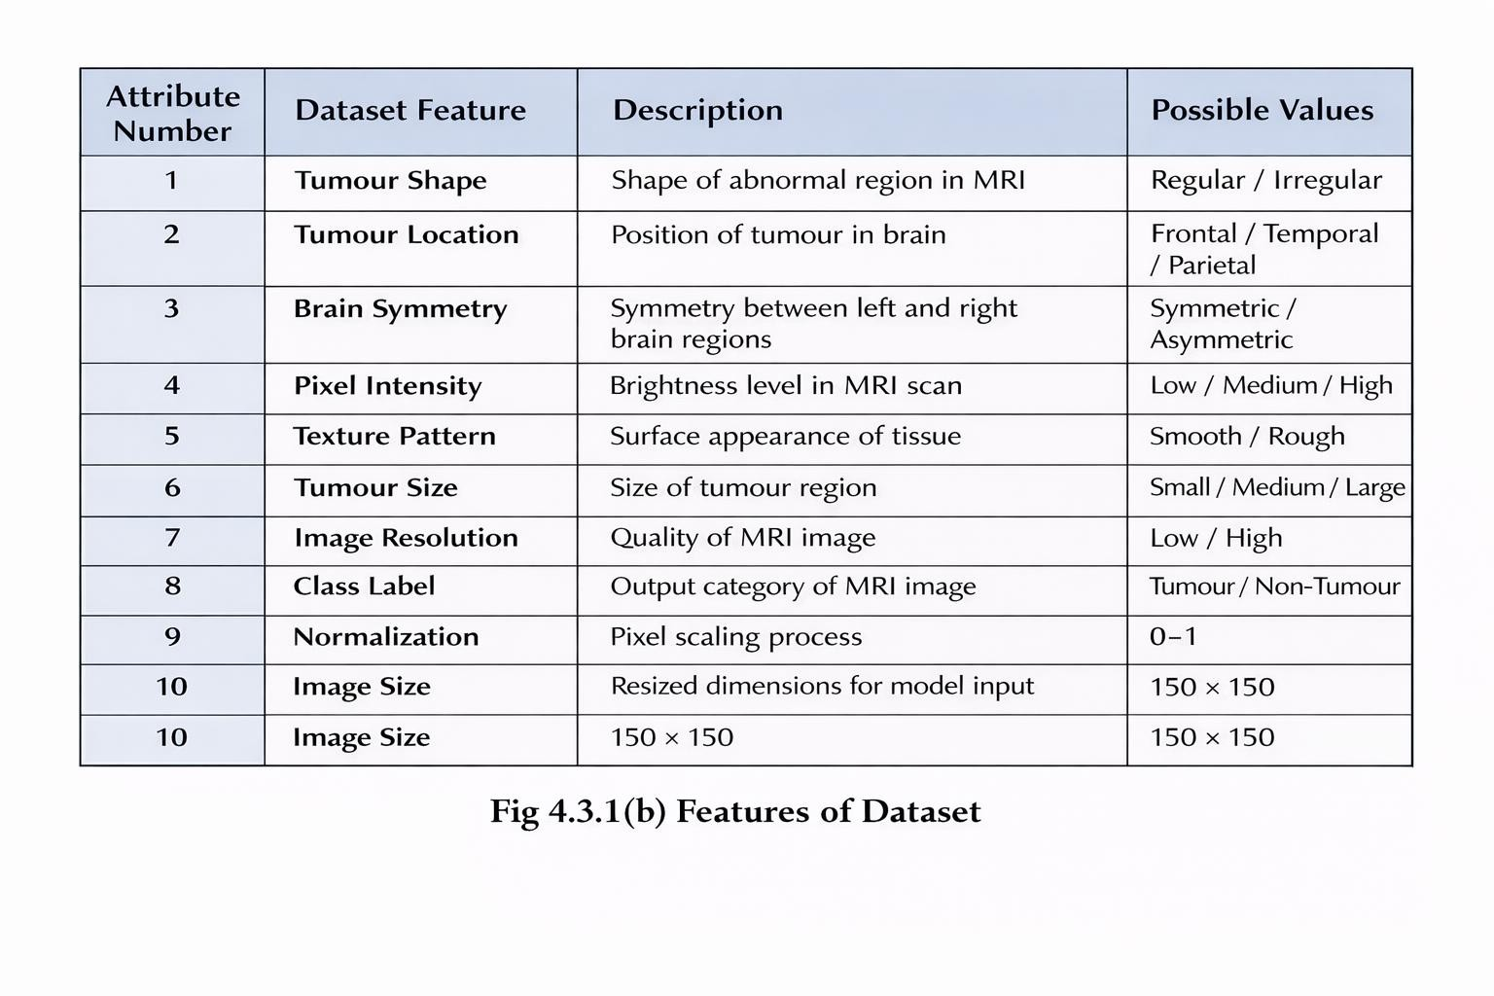

REQUIREMENTS SPECIFICATION

Requirement specification is an important stage in the development of the proposed Brain Tumour Detection System. It defines the necessary hardware, software, tools, and resources required for the successful implementation of the system. Requirement specification also helps in identifying the functionalities that the system should perform and the quality standards that it should maintain.

The proposed system requires an appropriate computing environment to perform image preprocessing, model training, prediction, and Grad-CAM visualization. Since the system is based on deep learning, it requires sufficient memory, storage, and processing power for handling MRI images and training the convolutional neural network model.

FUNCTIONAL REQUIREMENTS
Functional requirements describe the major operations that the proposed Brain Tumour Detection System is expected to perform. These requirements define how the system accepts MRI images, processes them, generates predictions, and presents the final output to the user.

Image Upload Function
The system should provide an option for the user to upload a brain MRI image for analysis. The uploaded image serves as the primary input to the system. Since the project is based on MRI image classification, the uploaded file should be in a valid image format such as JPG, JPEG, or PNG.

Image Preprocessing Function
Once the MRI image is uploaded, the system should automatically preprocess the image before sending it to the deep learning model. Preprocessing is necessary because MRI images collected from different sources may vary in size, brightness, and quality.
The preprocessing operations performed in the system include:
- Resizing the MRI image to 150 × 150 pixels
- Converting the image into numerical array format
- Normalizing pixel values to a range between 0 and 1
- Expanding image dimensions to match the model input shape
These preprocessing steps ensure that every MRI image is converted into a uniform format suitable for prediction.

Tumour Prediction Function
After preprocessing, the system should classify the MRI image into one of the following categories:
- Tumour
- Non-Tumour
The prediction is carried out using a trained deep learning model based on transfer learning with MobileNetV2. The model analyses the image and identifies whether abnormal tumour-related patterns are present in the brain MRI scan.

Confidence Score Display Function
The system should display the confidence score associated with the prediction result. The confidence score represents the probability value generated by the model for the predicted class.
For example:
- Tumour Detected – 94% Confidence
- Non-Tumour Detected – 91% Confidence
Displaying confidence values improves the reliability and interpretability of the prediction process.

Grad-CAM Visualization Function
One of the major features of the proposed system is Grad-CAM visualization. After generating the prediction, the system should highlight the important regions of the MRI image that contributed to the model’s decision.
Grad-CAM produces a heatmap over the MRI image, showing which part of the brain the model focused on while predicting tumour presence. This feature increases transparency and helps users understand the reasoning behind the model output.

Output Display Function
The system should present all prediction-related information in a clear and understandable format. The final output displayed to the user should include:
- Predicted class label
- Confidence score
- Grad-CAM heatmap
- Final tumour detection result

NON-FUNCTIONAL REQUIREMENTS
Non-functional requirements are the requirements which are not directly concerned with the specific function delivered by the system. They specify the criteria that can be used to judge the operation of a system rather than specific behaviors. They may relate to emergent system properties such as reliability, response time and store occupancy. Non-functional requirements arise through the user needs, because of budget constraints, organizational policies, the need for interoperability with other software and hardware systems or because of external factors such as:
- Product Requirements
- Organizational Requirements
- User Requirements
- Basic Operational Requirements

Product Requirements
Product requirements describe the quality and performance expected from the proposed system. Since the project is related to medical image analysis, the system should provide accurate and reliable predictions for both tumour and non-tumour MRI images.
The system should have a fast response time so that uploaded MRI images can be processed quickly without causing delays to the user. It should also generate Grad-CAM visualizations effectively so that users can understand which region of the MRI image influenced the prediction.

The system should maintain consistency in prediction results. If the same MRI image is uploaded multiple times, the system should provide the same output each time. Reliability and accuracy are important because the system is intended to assist in medical image analysis.

Organizational Requirements
Organizational requirements describe the technologies, tools, and software environment used for the development of the system. The proposed Brain Tumour Detection System is developed using Python as the programming language.
Several libraries and frameworks are used during development, including TensorFlow, Keras, NumPy, OpenCV, Matplotlib, and Streamlit. The system uses transfer learning with MobileNetV2 for feature extraction and classification.

The MRI dataset is organized into tumour and non-tumour folders, which helps in simplifying data loading and model training. Proper folder organization also improves maintainability and reduces complexity during implementation.

User Requirements
User requirements describe the needs and expectations of the end user while interacting with the system. The user should be able to upload a brain MRI image easily through the system interface.

After the image is uploaded, the system should display the prediction result clearly in the form of tumour or non-tumour classification. The confidence score should also be shown to help users understand how strongly the model supports the prediction.

The Grad-CAM heatmap should be displayed along with the original MRI image so that users can visually understand which region of the brain the model focused on. The interface should be simple, user-friendly, and understandable even for users with limited technical knowledge.

Basic Operational Requirements
Basic operational requirements describe the minimum hardware and software conditions needed for the proper functioning of the system. The proposed system should run on a computer with sufficient RAM, storage space, and processing capability.
The system should support standard image formats such as JPG, JPEG, and PNG for MRI image upload. It should also be capable of performing preprocessing, prediction, and Grad-CAM generation within a short period of time.

Some of them are as follows:

Accuracy
The system should provide highly accurate predictions for both tumour and non-tumour MRI images. Since the project is related to medical image analysis, prediction accuracy is one of the most important requirements. The deep learning model should correctly identify tumour- related patterns from MRI scans and minimize the number of false predictions.

Reliability
The proposed system should produce consistent results when different MRI images are provided as input. If the same image is uploaded multiple times, the system should generate the same prediction result each time. Reliability is important because users must be able to trust the model output.

Efficiency
The system should process MRI images within a short period of time. After uploading the image, preprocessing, prediction, and Grad-CAM generation should be completed quickly so that the user does not experience unnecessary delays. Efficient performance improves the usability of the system.

Usability
The system should be easy to use, even for users with limited technical knowledge. The interface should provide simple options for image upload, prediction, and result visualization. All outputs such as confidence score, tumour label, and Grad-CAM heatmap should be displayed clearly and understandably.

Scalability
The proposed system should be flexible enough to handle larger datasets in the future. Although the current implementation uses binary classification with tumour and non-tumour images, the system can later be extended to support multiple tumour categories or larger MRI datasets.

Maintainability
The system should be designed in such a way that future modifications can be made easily. New features such as additional preprocessing techniques, improved CNN architectures, or deployment modules can be added without significantly changing the entire system.

Security
The uploaded MRI images and prediction results should remain secure within the system. Since medical images may contain sensitive information, the system should ensure that user data is not exposed or misused.
Therefore, non-functional requirements help in improving the overall quality, reliability, and effectiveness of the proposed Brain Tumour Detection System.

PERFORMANCE REQUIREMENT
Performance requirements describe the expected efficiency and effectiveness of the proposed Brain Tumour Detection System. These requirements focus on how quickly, accurately, and reliably the system should perform its operations.
The system should be capable of processing MRI images within a short period of time. After the user uploads an MRI image, the preprocessing, prediction, and Grad-CAM generation should be completed quickly so that the user receives the result without significant delay.
The proposed system should provide high prediction accuracy for both tumour and non- tumour MRI images. Since the model is trained using a deep learning approach with transfer learning, it is expected to correctly identify important tumour-related patterns from MRI scans. Higher accuracy improves the usefulness and reliability of the system.
The system should also maintain low error rates during classification. False positives and false negatives should be minimized as much as possible because incorrect predictions may affect the usefulness of the model in medical image analysis.
Another important performance requirement is consistency. The system should produce stable and repeatable results when the same MRI image is provided multiple times. The prediction confidence and Grad-CAM output should remain consistent for identical inputs.
The memory usage and processing time of the system should also remain within acceptable limits. Since MRI images are resized to 150 × 150 pixels before training and prediction, the system can process images more efficiently without requiring excessive computational resources.
The performance of the model can be evaluated using different metrics such as:
- Accuracy
- Precision
- Recall
- F1-Score
- Loss Value

ML PACKAGES

Machine learning packages are important software components used for data preprocessing, model development, training, evaluation, and visualization. In the proposed Brain Tumour Detection System, different packages are used at various stages of the implementation process. These packages simplify the overall workflow and help in building an efficient deep learning model for MRI image classification.
The major machine learning packages used in this project are:

NumPy
NumPy is one of the fundamental packages used in the proposed Brain Tumour Detection System because deep learning models cannot process images directly in their original form. MRI images are first converted into numerical pixel arrays, and NumPy is used to handle these array-based computations efficiently. Each MRI image consists of thousands of pixel values, and NumPy helps in storing, accessing, reshaping, and manipulating these values in a structured way.

In this project, NumPy is mainly used during preprocessing and prediction stages. After reading the MRI image, it is converted into a NumPy array so that mathematical operations can be performed on it. NumPy is also used to normalize the pixel values by dividing them by 255, which scales the values between 0 and 1. This normalization improves the learning ability of the model and speeds up training. In addition, NumPy is used to reshape the image dimensions before giving it as input to the model. It is also used while handling prediction outputs, confidence scores, and converting the results into a readable format. Thus, NumPy plays an important role in managing the numerical data required throughout the project.

TensorFlow

TensorFlow is the main deep learning framework used in the proposed system. It provides the backend support required for creating, training, and evaluating the neural network model. TensorFlow is designed to handle complex mathematical operations involved in deep learning, such as matrix multiplication, gradient calculations, and optimization functions. Since brain tumour detection requires image classification using a CNN-based architecture, TensorFlow becomes one of the most important packages in the project.

In this project, TensorFlow is used to load the pretrained MobileNetV2 model and build the classification system on top of it. It helps in training the model using MRI images from tumour and non-tumour classes. TensorFlow also manages the forward propagation, backpropagation, loss calculation, and weight updates during training. In addition, it is used during prediction to classify the uploaded MRI image into tumour or non-tumour category. TensorFlow also supports Grad-CAM generation by allowing access to intermediate convolutional layers, which are required for highlighting important tumour regions in the image.

Keras

Keras is used in the project as a high-level interface for designing and implementing the deep learning model. Keras simplifies the model-building process by providing easy-to-use functions for adding layers, activation functions, optimizers, and evaluation metrics. Since TensorFlow can sometimes be complex to use directly, Keras helps in reducing coding complexity and makes the implementation more understandable.

In the proposed Brain Tumour Detection System, Keras is used to build the final model architecture using MobileNetV2 as the base model. Additional layers such as Global Average Pooling, Dense layers, Dropout layers, and Sigmoid output layer are added using Keras. It is also used for compiling the model with appropriate loss functions and optimizers. During training, Keras manages batch processing, epoch handling, validation, and performance tracking. After training is completed, the model is saved in a file format such as .h5, and Keras is again used to load this trained model during the prediction stage.

OpenCV

In this project, OpenCV is mainly used for reading MRI images from the dataset folders and resizing them to 150 × 150 pixels. This resizing process is necessary because the deep learning model requires all input images to have the same dimensions. OpenCV is also used for converting images into arrays and preparing them for normalization. During Grad-CAM visualization, OpenCV helps in resizing the heatmap and overlaying it on the original MRI image. This allows the highlighted tumour regions to be displayed clearly and improves the interpretability of the model’s prediction.

Matplotlib

Matplotlib is used for visualizing different outputs and performance metrics of the proposed system. Visualization is an important part of deep learning projects because it helps in understanding how the model behaves during training and how accurately it performs on new MRI images.

In this project, Matplotlib is used for displaying MRI images, plotting training accuracy graphs, plotting loss curves, and visualizing Grad-CAM heatmaps. During model training, graphs of accuracy and loss are generated to observe whether the model is learning properly or overfitting. After prediction, Matplotlib is used to show the original MRI image along with the predicted class label and highlighted tumour region. These visualizations make the project more informative and help users understand the output more clearly.

Scikit-learn

Scikit-learn is used in the project mainly for dataset preparation and evaluation purposes. Although the deep learning model itself is built using TensorFlow and Keras, Scikit-learn provides useful utility functions that support the training process.

In this project, Scikit-learn is used for splitting the dataset into training and testing sets. This is important because the model should be trained on one portion of the data and tested on another portion to measure its performance correctly. Scikit-learn is also used to calculate evaluation metrics such as accuracy, precision, recall, confusion matrix, and F1-score. These metrics provide a clear understanding of how effectively the model identifies tumour and non-tumour MRI images. Therefore, Scikit-learn helps in evaluating the reliability and overall performance of the proposed system.

Streamlit

Streamlit is used to create the front-end interface of the proposed Brain Tumour Detection System. It provides a simple way to convert the deep learning model into an interactive web application where users can upload MRI images and receive prediction results without running Python code manually.In this project, Streamlit is used to design an interface with image upload options, prediction buttons, and result display sections. After the user uploads an MRI image, Streamlit sends it to the trained model for prediction. It then displays the original MRI image, predicted result, confidence score, and Grad-CAM heatmap.

Streamlit makes the project more practical and user-friendly because it allows users to interact with the system easily through a browser-based environment.

ML LIBRARIES

Machine learning libraries are collections of predefined modules and functions that are imported into the program to perform specific tasks. These libraries help in simplifying coding complexity and allow the developer to implement preprocessing, model training, prediction, visualization, and evaluation more efficiently.
In the proposed Brain Tumour Detection System, several machine learning libraries are imported from TensorFlow, Keras, OpenCV, Matplotlib, NumPy, and Scikit-learn. Each library is used for a specific purpose during the implementation process.
- tensorflow.keras.preprocessing.image
- tensorflow.keras.models
- tensorflow.keras.layers
- tensorflow.keras.applications
- tensorflow.keras.optimizers
- sklearn.model_selection
- sklearn.metrics
- cv2
- numpy
- matplotlib.pyplot

tensorflow.keras.preprocessing.image
This library is used for loading, preprocessing, and converting MRI images into suitable formats for training and prediction. It helps in image resizing, image array conversion, and data preparation.

tensorflow.keras.models
This library is used for creating, compiling, saving, and loading the deep learning model. It supports model training and prediction processes.

tensorflow.keras.layers
This library provides different neural network layers such as Dense, Dropout, GlobalAveragePooling2D, and Input layers. These layers are used while building the final model architecture.

tensorflow.keras.applications
This library is used for accessing pretrained deep learning models. In this project, it is mainly used to import MobileNetV2 for transfer learning.

tensorflow.keras.optimizers
This library is used for selecting optimization algorithms such as Adam optimizer, which helps in minimizing loss and improving model accuracy during training. sklearn.model_selection
This library is used for splitting the dataset into training and testing sets. It helps in
organizing the data properly before model training.

sklearn.metrics
This library is used for calculating performance evaluation metrics such as accuracy, precision, recall, confusion matrix, and F1-score.

cv2
The cv2 library from OpenCV is used for image reading, resizing, heatmap generation, and overlaying Grad-CAM outputs on MRI images.

numpy
The numpy library from NumPy is used for array handling, normalization, reshaping, and prediction processing.

matplotlib.pyplot
The matplotlib.pyplot library from Matplotlib is used for plotting graphs, displaying MRI images, and visualizing Grad-CAM outputs.

ABOUT THE TECHNOLOGY / SOFTWARE

MACHINE LEARNING AND DEEP LEARNING

Machine learning is a branch of artificial intelligence that enables computers to learn patterns from data and make decisions without being explicitly programmed for every task. Instead of manually defining rules, machine learning models learn from examples and improve their performance through training.

Deep learning is an advanced subfield of machine learning that uses neural networks with multiple layers to learn complex patterns from large amounts of data. It is especially useful for image classification, object detection, speech recognition, and medical image analysis. Deep learning models are capable of automatically extracting important features from images without requiring manual feature selection.

The proposed Brain Tumour Detection System is mainly based on deep learning because MRI images contain complex visual patterns that are difficult to analyze using traditional methods. In this project, a Convolutional Neural Network (CNN) approach is used for classifying MRI images into tumour and non-tumour categories.

The system uses transfer learning with MobileNetV2, which is a pretrained deep learning model. Instead of training the entire model from the beginning, MobileNetV2 is used to extract important image features such as tumour shape, texture, intensity, and structural variations from MRI scans. Additional layers are then added to perform binary classification.

Deep learning is suitable for this project because it provides better accuracy, automatic feature extraction, and improved performance when compared to traditional machine learning methods. It also supports Grad-CAM visualization, which helps in identifying the important tumour regions that influenced the prediction.

Therefore, machine learning and deep learning form the core technology behind the proposed Brain Tumour Detection System.
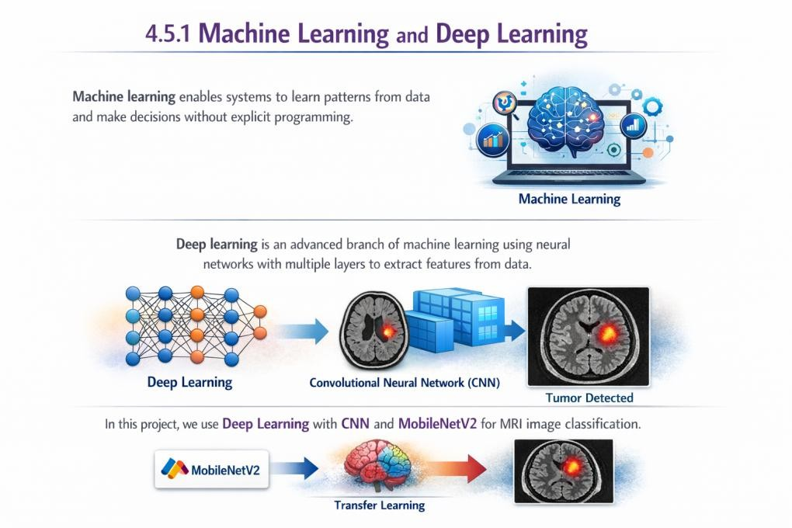

Fig 4.5.1 Brain Tumour Detection using Machine Learning and Deep Learning

PYTHON
Python is a powerful high-level, object-oriented programming language created by Guido van Rossum. Python is a general-purpose language. It has a wide range of applications from Web development (like: Django and Bottle), scientific and mathematical computing (Orange, SymPy, NumPy) to desktop graphical user Interfaces (Pygame, Panda3D).
In the late 1980s, Guido Van Rossum was working on the Amoeba distributed operating system group. He wanted to use an interpreted language like ABC (ABC has simple easy-to- understand syntax) that could access the Amoeba system calls. So, he decided to create a language that was extensible. This led to the design of a new language which was later named Python.
Python is a great and friendly language to use and learn. and can be adapted to both small and large projects. Python will cut a project's development time greatly and overall, it's much faster to write Python than other languages. Sometimes only Python code is used for a program, but most of the time it is used to do simple jobs while another programming language is used to do more complicated tasks. Its standard library is made up of many functions that come with Python when it is installed. Represent your data, a few of the most important machine learning algorithms, and how to evaluate the performance of your machine learning algorithm.
In the proposed Brain Tumour Detection System, Python is used as the main programming language for implementing the entire project. All stages of the system, including image preprocessing, model building, model training, prediction, Grad-CAM generation, and deployment, are performed using Python.
Python supports several important libraries such as TensorFlow, Keras, NumPy, OpenCV, Matplotlib, Scikit-learn, and Streamlit, which are required for the successful implementation of the project. These libraries simplify the tasks of handling MRI images, training the deep learning model, evaluating performance, and creating the user interface.
Python is also preferred because it provides better flexibility and compatibility with deep learning frameworks. Since the proposed system uses transfer learning with MobileNetV2, Python makes it easier to import pretrained models, customize them, and perform prediction efficiently.

      - TENSORFLOW AND KERAS

TensorFlow and Keras are the two main frameworks used in the proposed Brain Tumour Detection System for developing the deep learning model.

TensorFlow is an open-source deep learning framework developed for building, training, and evaluating neural network models. It is capable of handling large-scale numerical computations and supports efficient model training. TensorFlow is mainly used as the backend framework in this project.

Keras is a high-level API that runs on top of TensorFlow. It provides simple functions for creating layers, compiling models, selecting optimizers, and performing training. Keras reduces coding complexity and makes the model development process easier to understand.

In this project, TensorFlow and Keras are used for implementing the CNN-based classification model. They are also used for loading the pretrained MobileNetV2 model, adding custom layers, training the model on MRI images, saving the trained model, and loading it again during prediction.

The integration of TensorFlow and Keras makes the project more efficient because it combines the computational power of TensorFlow with the simplicity of Keras. This helps in building an accurate and reliable system for brain tumour detection.
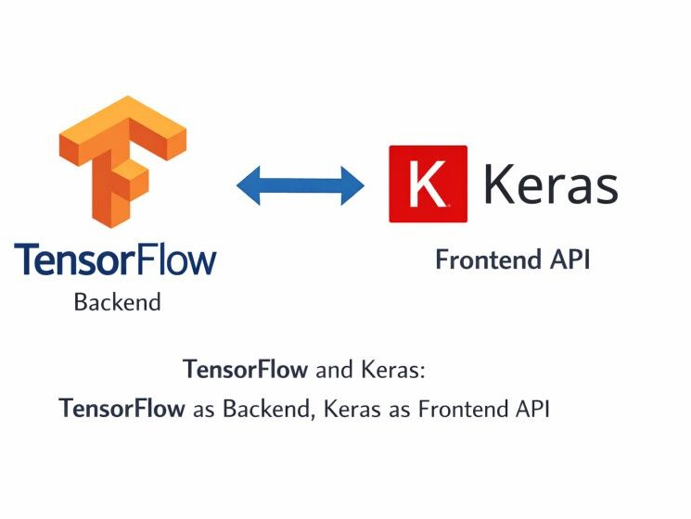

Fig 4.5.3 TensorFlow–Keras Architecture

OPENCV

OpenCV is an open-source computer vision library used for image preprocessing in the proposed system. MRI images collected from different sources may vary in size, brightness, and quality, so preprocessing becomes necessary before model training.
In this project, OpenCV is used for reading MRI images, resizing them to 150 × 150 pixels, converting them into arrays, and preparing them for normalization. These preprocessing steps ensure that all images are converted into a uniform format before they are given to the deep learning model.
OpenCV is also used during Grad-CAM generation for resizing the heatmap and overlaying it on the original MRI image. This helps in highlighting the tumour-affected regions that influenced the model’s prediction.
Thus, OpenCV is important because it supports efficient image handling and preprocessing operations required for brain tumour detection.
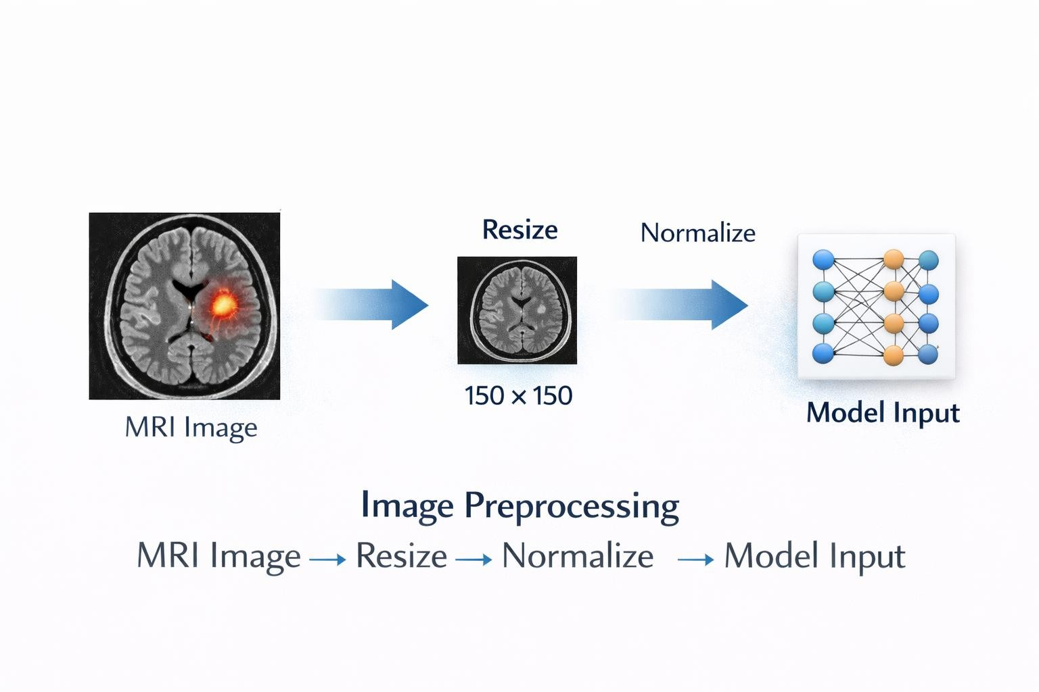

    - Image Preprocessing Pipeline

MOBILENETV2
MobileNetV2 is a pretrained deep learning model used in the proposed Brain Tumour Detection System for transfer learning. Transfer learning is a technique in which a model that has already been trained on a large dataset is reused for a new classification task.
MobileNetV2 is selected in this project because it is lightweight, efficient, and capable of extracting important image features with fewer computational resources. It can identify patterns such as edges, textures, tumour shapes, and structural abnormalities present in MRI images.
Instead of training an entirely new CNN model from the beginning, MobileNetV2 is used as the base model for feature extraction. Additional layers such as Dense layers, Dropout layers, and a Sigmoid output layer are added to classify the MRI image into tumour or non-tumour category.
Using MobileNetV2 improves the performance of the model because it reduces training time and provides better accuracy even with a limited dataset. It also helps in improving generalization and reduces the chances of overfitting.
Therefore, MobileNetV2 is one of the most important technologies used in the project because it provides the core feature extraction capability required for brain tumour detection.
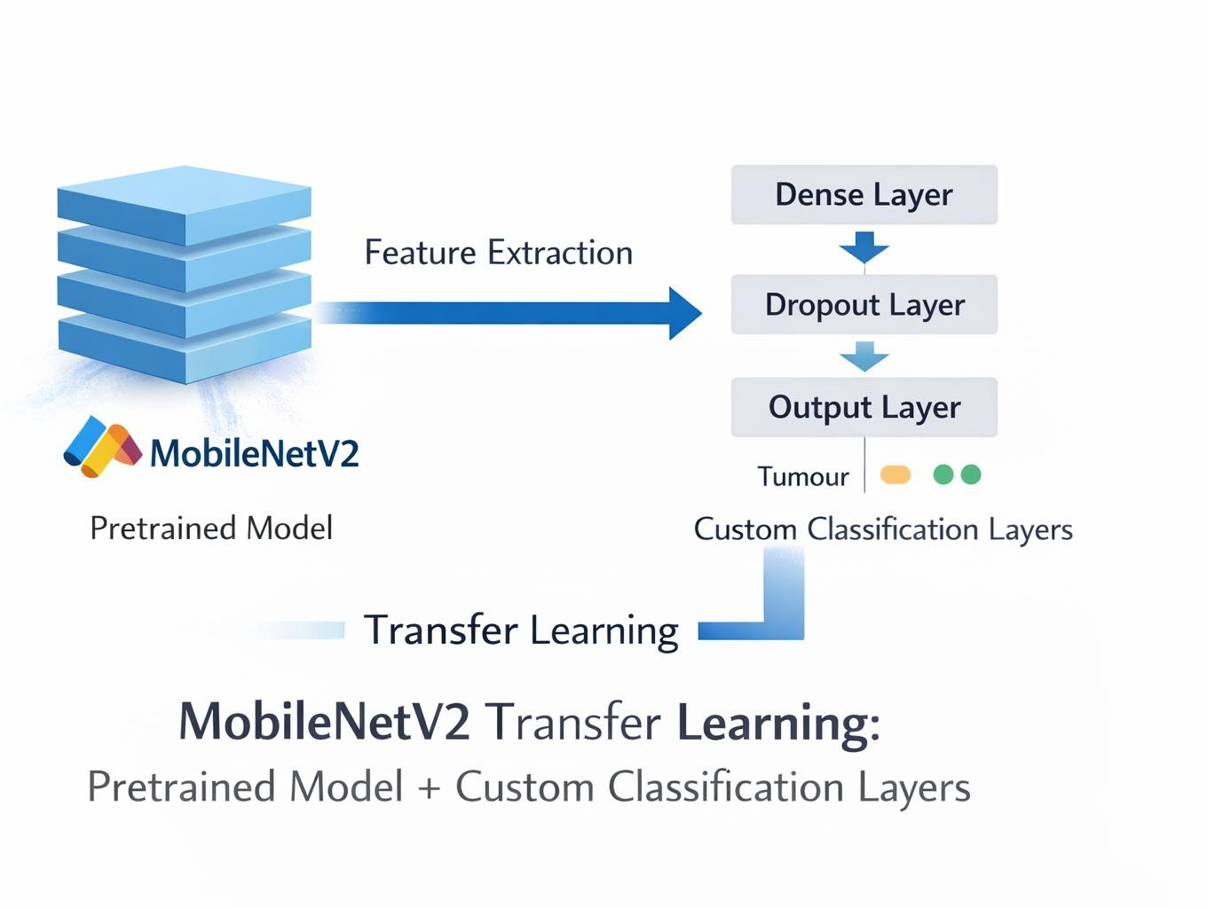
    - MobileNetV2 Transfer Learning

GRAD-CAM

Grad-CAM stands for Gradient-weighted Class Activation Mapping. It is a visualization technique used to understand which regions of an image influenced the prediction made by the deep learning model.
In the proposed Brain Tumour Detection System, Grad-CAM is used after prediction to highlight the important regions of the MRI image that contributed to the classification result. It generates a heatmap that is superimposed on the original MRI image.
If the image contains a tumour, Grad-CAM highlights the suspicious tumour region in bright colors, showing where the model focused its attention. This improves the interpretability and transparency of the model because users can visually understand the reason behind the prediction.
Grad-CAM is one of the most important features of the proposed system because it makes the model more explainable and reliable.

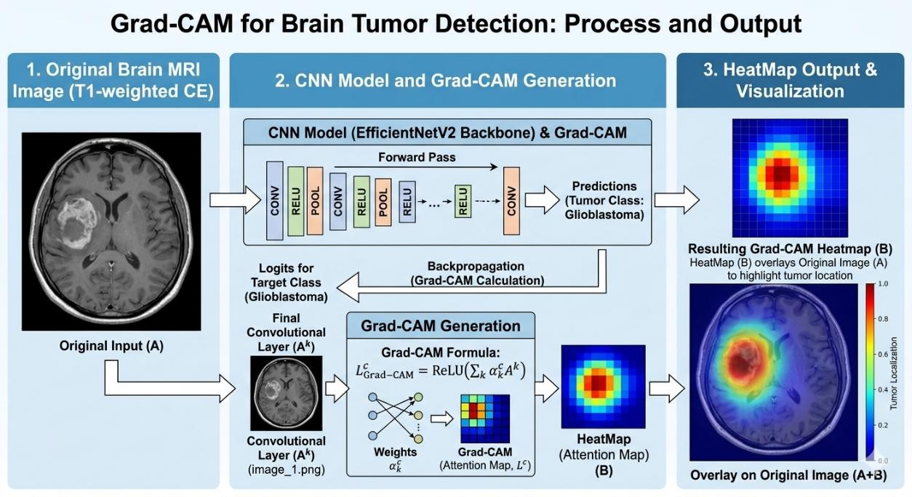

    - Grad-CAM Visualization Process

VISUAL STUDIO CODE
Visual Studio Code is the main code editor used for implementing the proposed Brain Tumour Detection System. It is a lightweight and powerful development environment that supports Python programming and machine learning libraries.
In this project, Visual Studio Code is used for writing Python scripts, training the deep learning model, implementing Grad-CAM, testing prediction outputs, and developing the Streamlit interface. It provides useful features such as syntax highlighting, code suggestions, debugging support, and integrated terminal access.
Visual Studio Code also allows easy installation of Python extensions and helps in managing project files efficiently. Therefore, it plays an important role in simplifying the coding and development process.

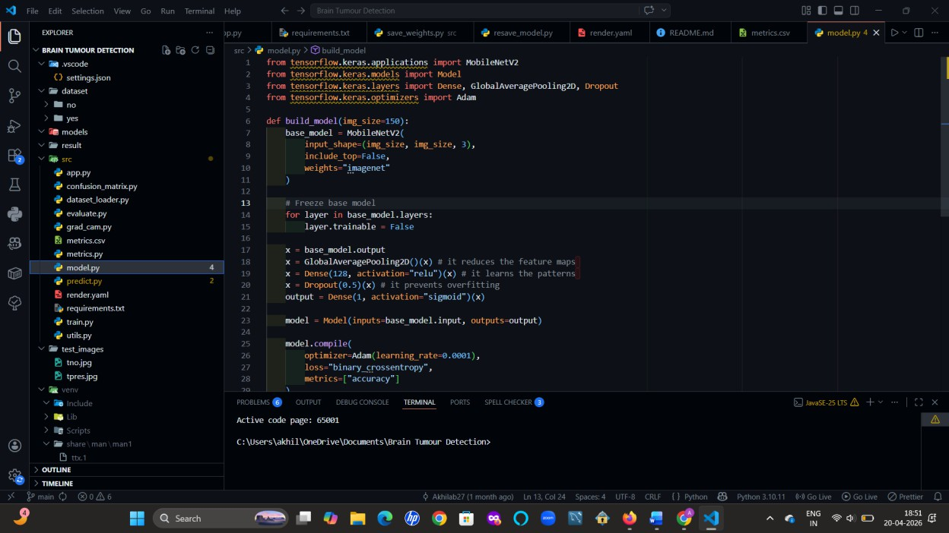

Fig 4.5.7 Visual Studio Code Environment

SYSTEM DESIGN

SYSTEM DESIGN

MODULE DESCRIPTION
The proposed Brain Tumour Detection System is divided into different modules to simplify the implementation process and improve system organization. Each module performs a specific task, starting from dataset collection and preprocessing to final prediction and visualization. The modular structure helps in reducing complexity and makes the system easier to understand, implement, and maintain.
Entire project is divided into 3 modules as follows:

- Data Gathering and pre processing

- Training the model using following Machine Learning algorithms

- Final Prediction Model integrated with frontend

Module 1: Data Gathering and Data Pre processing

The first module of the proposed Brain Tumour Detection System is Data Gathering and Data Preprocessing. This module is considered one of the most important parts of the project because the quality of the dataset directly affects the accuracy and performance of the deep learning model.
In this project, the dataset consists of brain MRI images collected and organized into two categories: tumour and non-tumour. These images are stored in separate folders so that the model can learn the difference between normal and abnormal brain conditions. The dataset includes MRI scans with different intensity levels, textures, shapes, and structural patterns, which help the model learn important tumour-related features.
Since the MRI images are collected from different sources, they may not all have the same size, quality, or brightness. Therefore, preprocessing is necessary before the images can be used for training. In the preprocessing stage, each MRI image is resized to 150 × 150 pixels so that all images have a uniform dimension. After resizing, the image is converted into numerical array format because deep learning models cannot process raw images directly.
The pixel values of the MRI image are then normalized between 0 and 1 by dividing them by 255. This normalization process improves training efficiency and helps the model converge faster. The images are also labeled according to their category.

Module 2: Training the model

The second module of the proposed Brain Tumour Detection System is Training the Model. This module is the core part of the project because it enables the system to learn how to classify MRI brain images into tumour and non-tumour categories. The performance of the final prediction system mainly depends on how effectively the model is trained using the available dataset.
In this project, a deep learning approach is used for training the model. Since MRI image classification is a complex task, a Convolutional Neural Network (CNN) based transfer learning method is selected. The pretrained MobileNetV2 model is used as the base architecture because it provides strong feature extraction capability with fewer computational resources.
The training process begins after completing data preprocessing. The MRI dataset, which contains tumour and non-tumour images, is divided into training and testing sets. The training set is used for learning image patterns, while the testing set is used to evaluate the performance of the model on unseen data.

Steps Involved in Model Training
- Loading the Pretrained Base Model
The MobileNetV2 model is loaded without its original output layer. This allows the model to act as a feature extractor for MRI images. The pretrained weights help in identifying important visual features such as edges, shapes, textures, and structural variations.

Adding Custom Classification Layers
After loading MobileNetV2, additional layers are added to customize the model for binary classification. These layers include:
  - Global Average Pooling Layer
  - Dense Layer
  - Dropout Layer
  - Output Layer with Sigmoid Activation

Model Compilation
After building the architecture, the model is compiled using:
  - Optimizer: Adam

  - Loss Function: Binary Crossentropy
  - Evaluation Metric: Accuracy
The optimizer updates model weights during training, while the loss function measures prediction error.

Training Process
The model is trained using the training dataset for multiple epochs. During each epoch, the model processes all training images, compares predicted outputs with actual labels, calculates loss, and updates internal parameters.
As training progresses, the model gradually learns tumour-related patterns such as:
  - Abnormal mass structures
  - Intensity changes
  - Shape irregularities
  - Tissue texture differences

Validation and Performance Monitoring
During training, validation data is used to monitor model performance. Accuracy and loss graphs are generated to check whether the model is learning properly or overfitting.

Saving the Trained Model
After successful training, the final model is saved into a file so that it can be loaded later during prediction through the Streamlit interface.

Importance of This Module
This module gives intelligence to the proposed system. Without proper training, the system cannot correctly detect tumours from MRI images. The use of MobileNetV2 improves training speed, reduces computational cost, and increases classification accuracy.

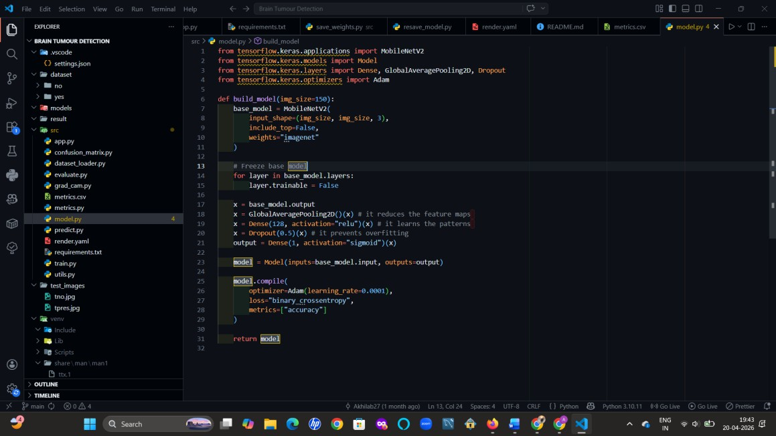
Fig 5.1.1: Model Training Using MobileNetV2 Architecture

Module 3: Final Prediction model integrated with front end

The third module of the proposed Brain Tumour Detection System is the Final Prediction Model Integrated with Frontend. This module combines the trained deep learning model with an interactive user interface so that users can easily upload MRI images and obtain prediction results. It is the final implementation stage where the developed model is converted into a practical real-time application.
In this project, the frontend interface is developed using Streamlit, which is a Python- based framework used for building simple and effective web applications for machine learning systems. Streamlit is selected because it provides an easy way to connect the trained model with a user-friendly graphical interface.
The working process of this module begins when the user uploads a brain MRI image through the Streamlit application. The uploaded image is displayed on the screen and then sent to the preprocessing module. In preprocessing, the image is resized to 150 × 150 pixels, normalized, and converted into array format so that it matches the input shape required by the trained model.
After preprocessing, the image is passed to the trained MobileNetV2-based deep learning model. The model analyzes the MRI image and extracts important visual features

related to tumour patterns, texture abnormalities, and structural changes in brain tissues. Based on the learned patterns, the model predicts whether the image belongs to the tumour or non-tumour class.
The prediction result is then displayed on the frontend interface along with the confidence score. The confidence score indicates how strongly the model supports the generated prediction. This helps users understand the reliability of the output.
An additional feature included in this module is Grad-CAM visualization. After prediction, the Grad-CAM module generates a heatmap on the MRI image, highlighting the region where the model focused while making the decision. If a tumour is present, the suspicious tumour region is highlighted more prominently. This improves transparency and trust in the system.
The final output screen displays:

- Uploaded MRI Image

- Prediction Result (Tumour / Non-Tumour)

- Confidence Score

- Grad-CAM Heatmap

- Final Analysis Output
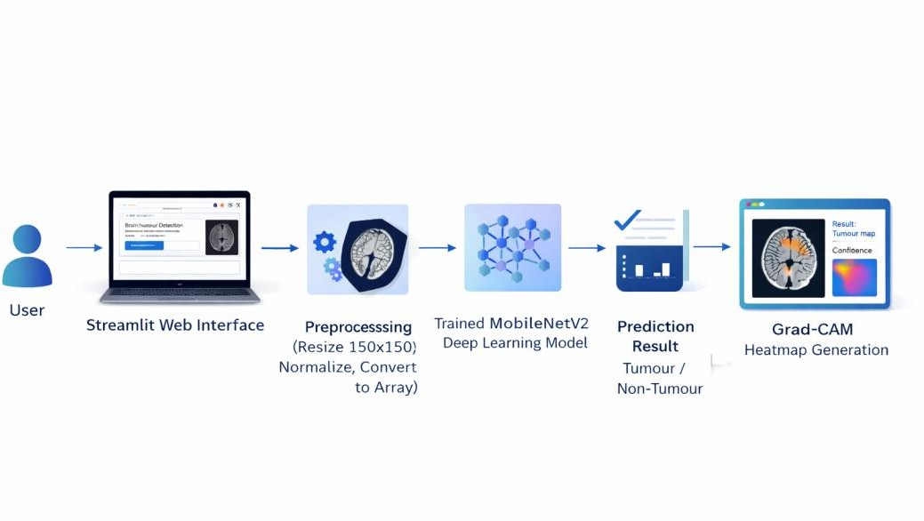

Figure 5.1.2 Final Prediction Model Integrated with Frontend

SYSTEM ARCHITECTURE

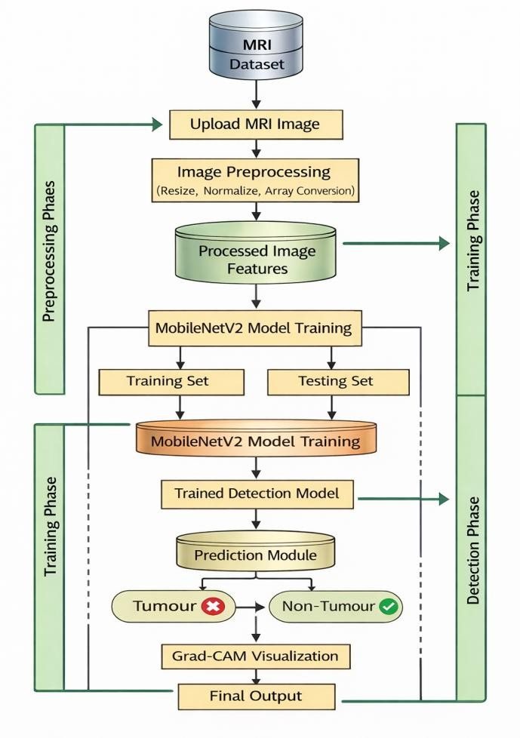

Fig 5.2 System Architecture

System architecture represents the overall structural design of the proposed Brain Tumour Detection System. It describes how different hardware and software components are organized and how they interact with each other to perform tumour detection from MRI brain images. A clear system architecture helps in understanding the complete workflow of the project from image input to final prediction output.
The proposed system is designed using a modular architecture that combines image preprocessing, deep learning classification, visualization techniques, and a user-friendly frontend interface. Each module performs a specific task and collectively contributes to accurate brain tumour detection.
The architecture begins with the user interface module, where the user uploads a brain MRI image through the Streamlit web application. This interface acts as the communication

layer between the user and the prediction system. It allows easy image upload and displays final results in an understandable format.
Once the MRI image is uploaded, the image is sent to the preprocessing module. In this stage, the uploaded image undergoes several operations such as resizing, normalization, and conversion into numerical array format. In the proposed system, each image is resized to 150
× 150 pixels to maintain consistency with the input shape required by the trained deep learning model. Normalization is performed to scale pixel values between 0 and 1, which improves model performance.
After preprocessing, the processed image is forwarded to the classification module, which contains the trained deep learning model based on MobileNetV2 architecture. This module extracts meaningful image features such as tumour shape, texture patterns, structural abnormalities, and intensity variations. Based on these learned features, the model classifies the image into one of the following categories:
- Tumour
- Non-Tumour
The prediction result generated by the model is then passed to the output module, where the class label and confidence score are displayed to the user. The confidence score represents the probability associated with the predicted result. To improve transparency and interpretability, the system also includes a Grad-CAM visualization module. This module highlights the important regions of the MRI image that influenced the model’s decision. If the image contains a tumour, the suspicious tumour region is shown using a heatmap overlay.
The final output screen of the system displays:
- Uploaded MRI Image
- Prediction Result
- Confidence Score
- Grad-CAM Heatmap
- Final Decision .

DATA FLOW DIAGRAMS

Data Flow Diagram (DFD) is a graphical representation used to describe how data moves through the proposed system. It shows the flow of information between users, processes, data stores, and outputs. DFD helps in understanding how input data is transformed into meaningful output through different processing stages.

In the proposed Brain Tumour Detection System, the Data Flow Diagram illustrates how MRI images are uploaded by the user, processed through preprocessing techniques, analyzed by the trained deep learning model, and finally converted into prediction results with Grad- CAM visualization.

The main purpose of using DFD is to represent the logical flow of data in a clear and structured manner. It helps in understanding the interaction between different modules such as user interface, preprocessing module, classification model, and output module.

DATA FLOW DIAGRAM LEVEL 0
Data Flow Diagram Level 0 is also known as the Context Diagram. It represents the proposed Brain Tumour Detection System as a single process and shows the interaction between the external user and the system. This level gives a high-level overview of the complete system without describing internal modules in detail.
In the proposed system, the user acts as the external entity who provides the input MRI image to the system. The Brain Tumour Detection System receives the uploaded MRI image, processes it internally, and returns the prediction result to the user.
The main input provided by the user is a brain MRI image. After receiving the image, the system performs preprocessing, classification, and visualization operations internally. Finally, the system sends the following outputs back to the user:
Tumour / Non-Tumour Prediction Confidence Score
Grad-CAM Heatmap Final Output Result
The Level 0 DFD is useful for understanding the basic communication between the user and the proposed system.

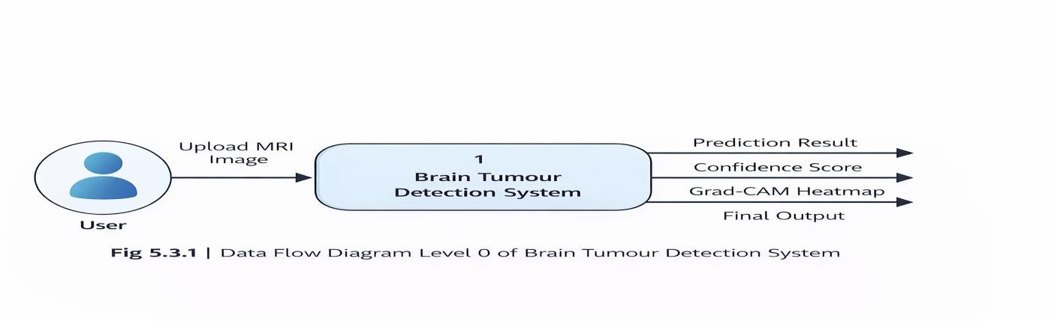
Fig 5.3.1 DFD Level 0

DATA FLOW DIAGRAM LEVEL 1

Data Flow Diagram Level 1 provides a more detailed representation of the proposed Brain Tumour Detection System by breaking the main system process into smaller sub- processes. Unlike Level 0, which shows the system as a single unit, Level 1 explains the major internal operations performed by the system.

In the proposed system, the main process is divided into different functional modules such as image upload, preprocessing, prediction, visualization, and output generation. These modules work together to convert the uploaded MRI image into a meaningful prediction result.

The Level 1 DFD begins when the user uploads a brain MRI image through the frontend interface. The image is then transferred to the preprocessing module, where operations such as resizing, normalization, and array conversion are performed. After preprocessing, the processed image is sent to the trained MobileNetV2 deep learning model for classification.
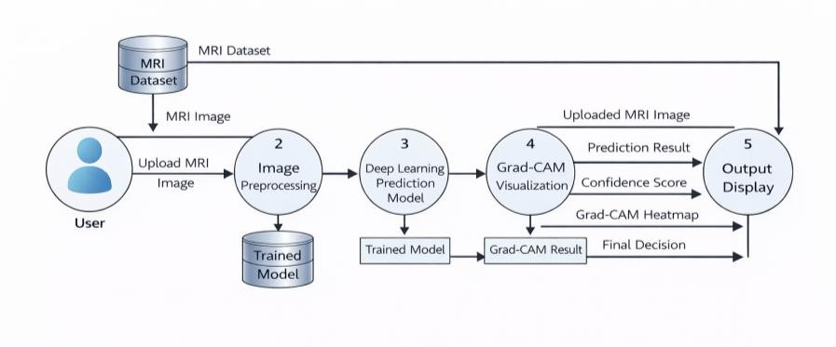

Fig 5.3.2 DFD Level 1

DATA FLOW DIAGRAM LEVEL 2
Data Flow Diagram Level 2 gives a more detailed explanation of one important internal process of the proposed Brain Tumour Detection System. In this project, Level 2 mainly focuses on the internal working of the prediction module, where the uploaded MRI image is processed and classified using the trained deep learning model.
At this level, the prediction process is divided into smaller steps such as image loading, resizing, normalization, feature extraction, classification, confidence score generation, and Grad-CAM visualization. This helps in understanding how the system transforms a raw MRI image into an accurate prediction result.
The Level 2 process begins when the uploaded MRI image is received from the user interface. The image is then resized to 150 × 150 pixels and normalized so that it matches the input format of the trained MobileNetV2 model. After preprocessing, the image is sent to the feature extraction stage, where the deep learning model identifies tumour-related patterns such as texture irregularities, abnormal masses, and structural differences.
The extracted features are then passed to the classification layer, which predicts one of the following outputs:
      - Tumour

      - Non-Tumour

After classification, the system calculates the confidence score of the prediction. Then, the Grad-CAM module generates a heatmap to highlight the important regions responsible for the prediction. Finally, all outputs are displayed to the user through the frontend interface.

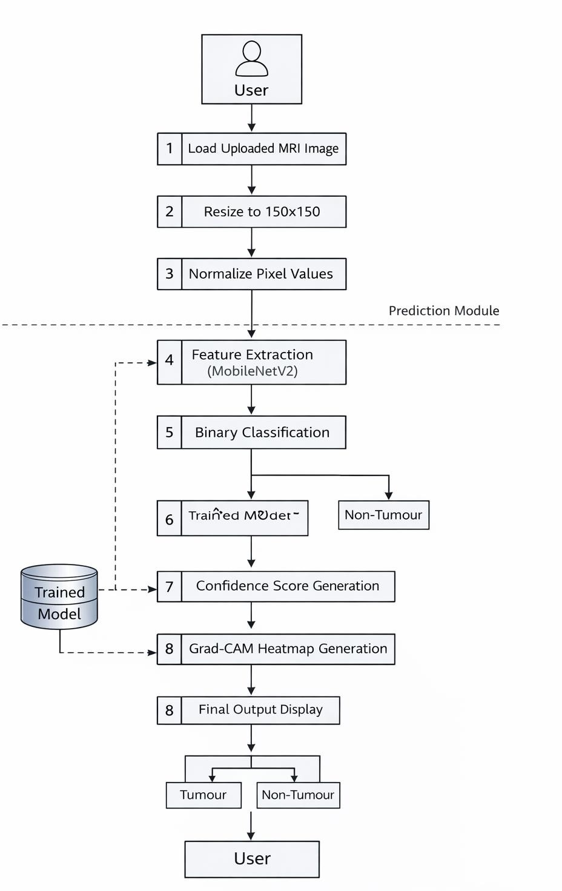

Fig 5.3.3 DFD Level 2

UML DIAGRAMS

USE CASE DIAGRAM
In UML, use-case diagrams model the behaviour of a system and help to capture the requirements of the system. Use-case diagrams describe the high-level functions and scope of a system. These diagrams also identify the interactions between the system and its actors. The use cases and actors in use-case diagrams describe what the system does and how the actors use it, but not how the system operates internally. Use-case diagrams illustrate and define the context and requirements of either an entire system or the important parts of the system. You can model a complex system with a single use-case diagram, or create many use-case diagrams to model the components of the system. You would typically develop use- case diagrams in the early phases of a project and refer to them throughout the development process.
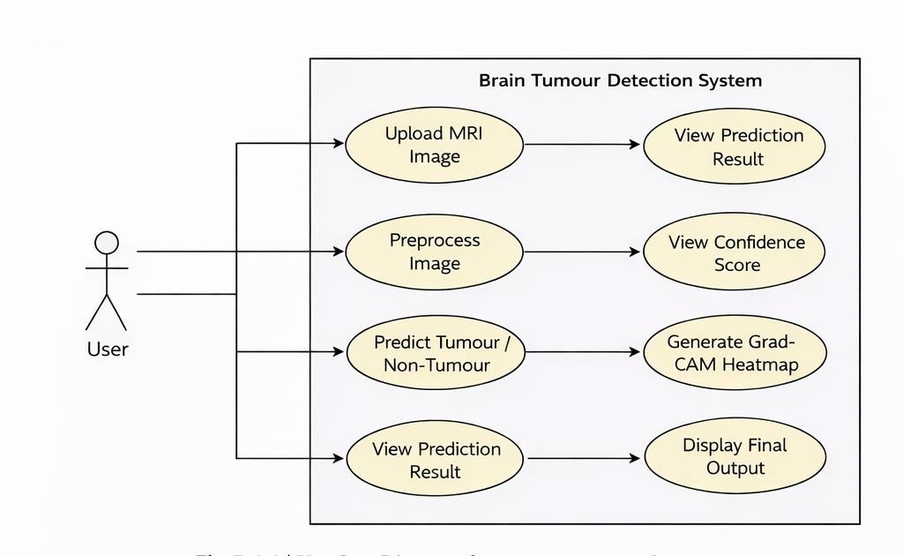
Figure 5.4.1 Use Case Diagram

Figure 5.4.1 shows how the user interacts with the proposed Brain Tumour Detection System to obtain tumour detection results from MRI images. The user first uploads a brain MRI image through the frontend interface. After receiving the image, the system performs preprocessing operations such as resizing and normalization. The preprocessed image is then passed to the trained MobileNetV2 model, which predicts whether the image belongs to tumour or non-tumour class. After prediction, the system displays the result along with confidence score. The Grad-CAM module is then used to generate a heatmap showing the region responsible for the prediction. Thus, the Use Case Diagram visually represents the major functionalities and user interactions of the proposed system.

    - ACTIVITY DIAGRAM
Activity diagram is an important diagram in UML to describe the dynamic aspects of the system. Activity diagram is basically a flowchart to represent the flow from one activity to another activity. The activity can be described as an operation of the system. The control flow is drawn from one operation to another. This flow can be sequential, branched, or concurrent. Activity diagrams deal with all type of flow control by using different elements such as fork, join, etc. The basic purposes of activity diagram are it captures the dynamic behavior of the system. Activity diagram is used to show message flow from one activity to another Activity is a particular operation of the system. Activity diagrams are not only used for visualizing the dynamic nature of a system, but they are also used to construct the executable system by using forward and reverse engineering techniques. The only missing thing in the activity diagram is the message part.
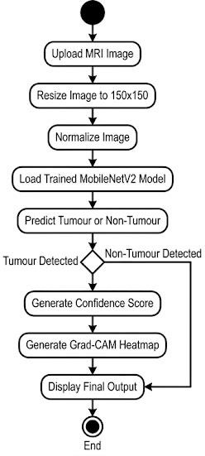

Figure 5.4.2 Activity Diagram

SEQUENCE DIAGRAM
The sequence diagram represents the flow of messages in the system and is also termed as an event diagram. It helps in envisioning several dynamic scenarios. It portrays the communication between any two lifelines as a time-ordered sequence of events, such that these lifelines took part at the run time. In UML, the lifeline is represented by a vertical bar, whereas the message flow is represented by a vertical dotted line that extends across the bottom of the page. It incorporates the iterations as well as branching.
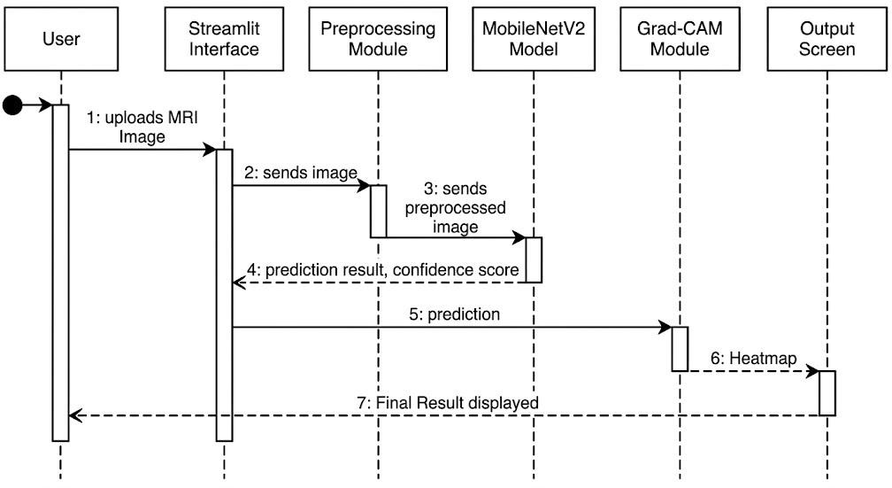

Figure 5.4.3 Sequence Diagram
Figure 5.4.3 explains the communication between various modules of the proposed Brain Tumour Detection System. Initially, the user uploads an MRI image through the Streamlit interface. The interface sends the image to the preprocessing module for resizing and normalization. After preprocessing, the image is forwarded to the MobileNetV2 deep learning model for classification. The model returns the prediction result and confidence score. These outputs are then sent to the Grad-CAM module, which generates a heatmap showing the region of interest. Finally, the output screen displays the tumour prediction, confidence score, Grad-CAM heatmap, and uploaded MRI image to the user. The sequence diagram clearly represents the interaction between frontend and backend components of the proposed system.

IMPLEMENTATION AND RESULT ANALYSIS

IMPLEMENTATION AND RESULT ANALYSIS

INTRODUCTION

Implementation and Result Analysis is one of the most important phases of the proposed Brain Tumour Detection System. In this phase, the designed model is converted into a working application using deep learning techniques and suitable software tools. The system is implemented to detect the presence of brain tumour from MRI images automatically.

The proposed system is developed using Python programming language with TensorFlow and Keras libraries. MobileNetV2 transfer learning model is used for classification of MRI images into tumour and non-tumour classes. Image preprocessing techniques such as resizing and normalization are applied before prediction. The frontend of the system is developed using Streamlit, where users can upload MRI images and obtain prediction results along with confidence score and Grad-CAM heatmap visualization. This chapter explains the implementation of the proposed system, model performance analysis, deployment process, and prediction results obtained from test MRI images.

DEEP LEARNING MODEL

CONVOLUTIONAL NEURAL NETWORK
Convolutional Neural Network (CNN) is a deep learning model mainly used for image classification and feature extraction tasks. CNN automatically learns important image features such as edges, shapes, textures, and patterns without manual feature engineering.
In the proposed Brain Tumour Detection System, CNN principles are used to analyze MRI brain images and identify tumour-related abnormalities. The convolution layers extract useful features from MRI images, while pooling layers reduce image dimensions and improve efficiency. Fully connected layers perform final classification. CNN is highly suitable for medical image analysis because it can effectively detect hidden patterns present in MRI scans.

TRANSFER LEARNING
Transfer learning is a technique in which a pretrained deep learning model is reused for a new classification task. Instead of training a model from the beginning, previously learned weights are utilized to improve accuracy and reduce training time.

In the proposed Brain Tumour Detection System, transfer learning is applied using the MobileNetV2 model. The pretrained layers are used for feature extraction, and custom dense layers are added for tumour and non-tumour classification.

MOBILENETV2 ARCHITECTURE
MobileNetV2 is a lightweight and efficient deep learning architecture designed for image classification tasks. It uses depthwise separable convolutions, which reduce the number of parameters and computational cost while maintaining good accuracy.
In the proposed Brain Tumour Detection System, MobileNetV2 is used as the base pretrained model for feature extraction from MRI images. It helps in identifying important tumour-related patterns such as abnormal shapes, intensity variations, and structural changes in brain scans.

BINARY CLASSIFICATION LAYER
Binary classification is a process in which the model predicts one of two possible output classes. In the proposed Brain Tumour Detection System, the final classification layer is designed to identify whether the uploaded MRI image contains a tumour or not.
After feature extraction using MobileNetV2, custom dense layers are added to perform classification. The output layer uses a Sigmoid activation function, which produces probability values between 0 and 1.

GRAD-CAM EXPLAINABILITY
Grad-CAM (Gradient-weighted Class Activation Mapping) is an explainable AI technique used to visualize the regions of an image that influenced the model’s prediction. It improves transparency and helps users understand how the deep learning model makes decisions.
In the proposed Brain Tumour Detection System, Grad-CAM is used after prediction to generate a heatmap on the uploaded MRI image. If a tumour is present, the suspicious region is highlighted, showing where the model focused during classification.
This feature increases trust and interpretability of the system, especially in medical image analysis applications.

CODE FOR IMPLEMENTATION OF ALGORITHMS

Code For Importing Libraries
import streamlit as st import numpy as np import tensorflow as tf import cv2
import os
from PIL import Image import matplotlib.pyplot as plt
from tensorflow.keras.preprocessing.image import img_to_array
from tensorflow.keras.applications.mobilenet_v2 import preprocess_input from tensorflow.keras.models import load_model
from sklearn.metrics import confusion_matrix
from sklearn.metrics import ConfusionMatrixDisplay from sklearn.metrics import classification_report from dataset_loader import val_generator

Code For Training Dataset
from model import build_model
from dataset_loader import train_generator, val_generator model = build_model()
model.summary() model.compile(
optimizer='adam', loss='binary_crossentropy', metrics=['accuracy']
)
history = model.fit( train_generator, validation_data=val_generator, epochs=20
)
model.save("brain_tumor_cnn_model.h5") loss, accuracy = model.evaluate(val_generator)
print(f"Validation Accuracy: {accuracy * 100:.2f}%")

Code For Testing Model

import numpy as np
from tensorflow.keras.models import load_model from tensorflow.keras.preprocessing import image IMG_SIZE = 150
model = load_model("brain_tumor_cnn_model.h5") def predict_tumor(img_file):
img = image.load_img(img_file, target_size=(IMG_SIZE, IMG_SIZE)) img_array = image.img_to_array(img)
img_array = img_array / 255.0
img_array = np.expand_dims(img_array, axis=0) prediction = model.predict(img_array)
prob = prediction[0][0] return prob

Code For Computing The Model Performance
from sklearn.metrics import ( accuracy_score, precision_score, recall_score,
f1_score, confusion_matrix
)
from tensorflow.keras.models import load_model from dataset_loader import val_generator
import numpy as np
model = load_model("brain_tumor_cnn_model.h5", compile=False) y_true = val_generator.classes
predictions = model.predict(val_generator) y_pred = (predictions > 0.5).astype(int).flatten() accuracy = accuracy_score(y_true, y_pred) precision = precision_score(y_true, y_pred) recall = recall_score(y_true, y_pred)
f1 = f1_score(y_true, y_pred)
cm = confusion_matrix(y_true, y_pred) print(cm)

print(f"Accuracy: {accuracy*100:.2f}%") print(f"Precision: {precision*100:.2f}%") print(f"Recall: {recall*100:.2f}%") print(f"F1 Score: {f1*100:.2f}%")

Code For Dumping Final Model

from tensorflow.keras.models import load_model
model = load_model("brain_tumor_cnn_model.h5", compile=False) model.save_weights("brain_tumor_weights.weights.h5") print("Weights saved successfully")

Code For Displaying Results

st.subheader("Prediction Result") if prob >= 0.5:
result = "Tumor Detected" confidence = prob * 100
st.error(f"{result} ({confidence:.2f}% confidence)") else:
result = "No Tumor Detected" confidence = (1 - prob) * 100
st.success(f"{result} ({confidence:.2f}% confidence)")

st.metric("Accuracy", f"{accuracy:.2f}%") st.metric("Precision", f"{precision:.2f}%") st.metric("Recall", f"{recall:.2f}%")
st.metric("F1 Score", f"{f1:.2f}%")

st.image(image, caption="Uploaded MRI Scan") st.image(gradcam_img, caption="Tumor Focus Region")

PERFORMANCE EVALUATION OF MODEL
Performance evaluation is an important stage in the proposed Brain Tumour Detection System because it measures how accurately and efficiently the trained deep learning model predicts tumour presence from MRI images. After completion of training, the model is tested using validation MRI images that were not directly used during training. This helps in checking the generalization capability of the system.
The proposed model is developed using MobileNetV2 transfer learning architecture with custom binary classification layers. After training, the model performance is analyzed using standard evaluation metrics such as accuracy, precision, recall, F1-score, and confusion matrix. These metrics provide a complete understanding of the model’s prediction quality.
The obtained performance values of the proposed system are as follows:
- Accuracy : 92.0%
- Precision : 90.0%
- Recall : 91.0%
- F1 Score : 90.5% Accuracy
Accuracy represents the overall percentage of correctly classified MRI images. It indicates how many total predictions were correct out of all tested samples. The proposed system achieved 92.0% accuracy, which shows that the model performs well in distinguishing tumour and non- tumour MRI images.
Precision
Precision indicates how many MRI images predicted as tumour were actually tumour cases. It is an important metric because false positive predictions should be minimized in medical applications. The proposed system achieved 90.0% precision, showing reliable positive predictions.
Recall
Recall measures the ability of the model to correctly identify actual tumour cases. In healthcare systems, recall is highly important because missing a tumour case can lead to serious consequences. The proposed system achieved 91.0% recall, indicating strong tumour detection capability.

F1 Score
F1-score is the harmonic mean of precision and recall. It provides a balanced measure when both false positives and false negatives are important. The proposed model achieved 90.5% F1-score, demonstrating stable classification performance.

Confusion Matrix
Confusion matrix is used to compare actual classes with predicted classes. It helps in identifying:
- True Positives (Tumour correctly predicted)
- True Negatives (Non-tumour correctly predicted)
- False Positives
- False Negatives
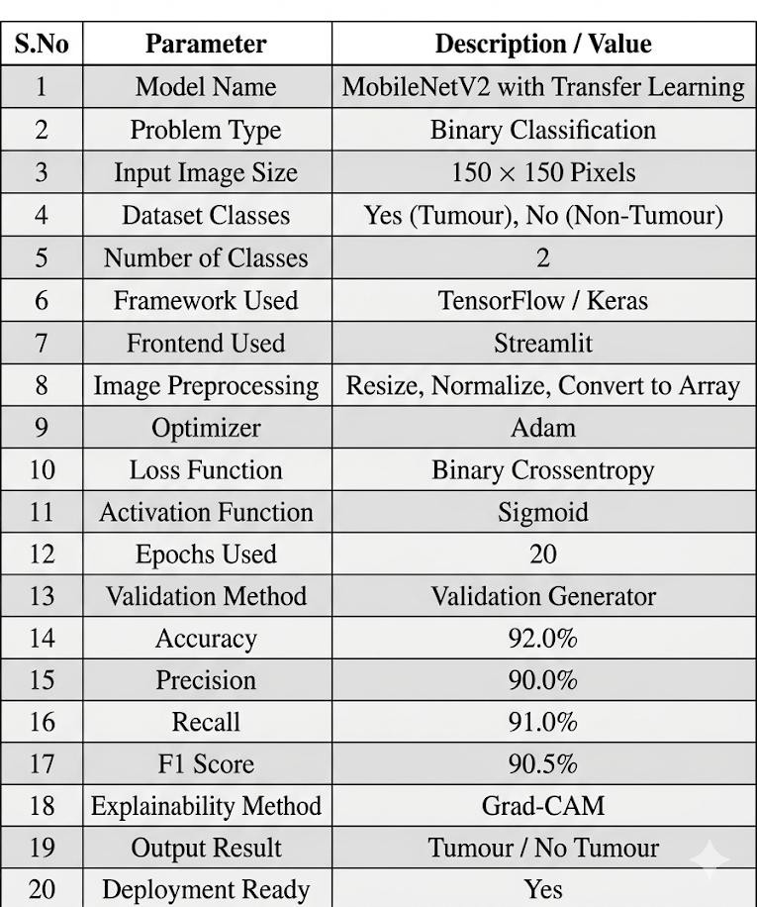

Table 6.4: Performance Evaluation

WHY MOBILENETV2 MODEL
MobileNetV2 is selected as the base model for the proposed Brain Tumour Detection System because it provides high classification accuracy with low computational complexity. It is a lightweight deep learning architecture specially designed for efficient image classification tasks.
The model uses depthwise separable convolutions, which reduce the number of parameters and training time compared to traditional CNN models. This makes MobileNetV2 faster and more memory efficient.
In the proposed system, MobileNetV2 is used with transfer learning to extract important features from MRI images such as abnormal shapes, texture variations, and tumour patterns. It performs well even with limited medical image datasets.
- High prediction accuracy
- Faster training process
- Low memory usage
- Suitable for real-time applications
- Effective feature extraction
- Better performance on image datasets

DEPLOYMENT
Deployment is the final stage of the proposed Brain Tumour Detection System, where the trained deep learning model is converted into a usable application for end users. In this project, deployment is carried out using Streamlit, which provides an interactive web-based interface for real-time prediction. The trained MobileNetV2 model and saved weights are integrated with the Streamlit frontend application. :
- Tumour / No Tumour Result
- Confidence Score
- Accuracy, Precision, Recall, F1 Score
- Grad-CAM Heatmap Visualization
- Final Clinical Summary

The application is executed locally using Visual Studio Code environment through the Streamlit server command.
The main advantages of deployment are:
- Easy user interaction
- Fast real-time prediction
- Simple web interface
- Explainable output using Grad-CAM
- Ready for future cloud deployment
Thus, deployment transforms the trained model into a practical application for brain tumour detection.

Python Code For Deployment App.py
import streamlit as st

st.set_page_config(
page_title="Brain Tumor Detection", page_icon="C˛*",
layout="wide"
)

st.title("C˛* Brain Tumor Detection System")
st.markdown("Upload an MRI scan to detect whether a brain tumor is present.")

// Upload Section

uploaded_file = st.file_uploader( "Upload MRI Image", type=["jpg", "jpeg", "png"]
)

PREDICTION

Prediction Results represent the final output generated by the proposed Brain Tumour Detection System after analyzing the uploaded MRI images. In this stage, the trained MobileNetV2 model predicts whether the given MRI scan contains a brain tumour or not.
The user uploads an MRI image through the Streamlit interface, and the system preprocesses the image before passing it to the trained model. Based on learned features, the model generates the final prediction along with confidence score.
The system provides two possible outputs:
- Tumour Detected
- No Tumour Detected
Along with the prediction result, the Grad-CAM heatmap is also displayed to highlight the region where the model focused during classification.
The final output screen displays:
- Uploaded MRI Scan
- Prediction Result
- Confidence Score
- Performance Metrics
- Grad-CAM Visualization
- Final Clinical Summary
The prediction results obtained from the proposed system indicate that the model can effectively classify MRI images with good accuracy and reliability.

TESTING

TESTING

METHODS OF TESTING

The main aim of the testing is to analyze the performance and to evaluate the errors that occur when the program is executed with different input sources and running in different operating environments.
In the proposed Brain Tumour Detection System, testing is carried out to check image upload functionality, preprocessing correctness, model prediction accuracy, output generation, and frontend performance. The system is tested using different MRI images containing tumour and non-tumour cases.
Testing helps to ensure that the trained deep learning model and Streamlit interface work properly under different conditions. It also confirms that the system provides reliable outputs with minimal errors.
The testing steps are:
- Unit Testing
- Integration Testing
- Functional Testing
- User Acceptance Testing
- System Testing
- Performance Testing

UNIT TESTING
Unit testing, also known as component testing refers to tests that verify the functionality of a specific section of code, usually at the function level. In an object- oriented environment, this is usually at the class level, and the minimal unit tests include the constructors and destructors. Unit testing is a software development process that involves synchronized application of a broad spectrum of defect prevention and detection strategies in order to reduce software development risks, time and costs. The following Unit testing table shows the functions that were tested at the time of programming. The first column gives all the modules which were tested, and the second column gives the test results. Test results indicate if the functions, for given inputs are delivering valid outputs.

INTEGRATION TESTING

Integration testing is used to verify whether different modules of the proposed system work together properly after combining them. In this project, the Streamlit frontend, preprocessing module, trained MobileNetV2 model, Grad-CAM module, and output display module are integrated. The uploaded MRI image from the frontend is checked whether it is correctly passed to preprocessing stage. After preprocessing, the image flow to prediction model is verified. The prediction output is tested whether it is correctly transferred to result display module. Grad-CAM heatmap generation after prediction is also verified. Any communication issues between modules are identified and corrected. Integration testing ensures smooth data transfer among all system components. It improves overall system reliability.

FUNCTIONAL TESTING

Functional testing is performed to verify whether the proposed Brain Tumour Detection System satisfies all required functionalities. Every feature of the application is tested based on user requirements. MRI image upload option is tested for supported image formats such as JPG, JPEG, and PNG. Prediction button functionality is verified after image upload. Tumour and non-tumour result generation is tested with multiple MRI images. Confidence score display is checked for correctness. Model performance metrics such as accuracy, precision, recall, and F1-score are tested. Grad-CAM heatmap visualization is also verified. Error messages for invalid inputs are checked. Functional testing ensures that the application performs all intended tasks properly. Thus, user requirements are successfully satisfied.

USER ACCEPTANCE TESTING

User Acceptance Testing is performed to verify whether the proposed system meets user expectations and practical usability requirements. The application interface is tested for simplicity and ease of use. Users are asked to upload MRI images and verify prediction outputs. The clarity of displayed results such as tumour detection, confidence score, and Grad-CAM heatmap is checked. Navigation and interaction with the Streamlit interface are tested. Users verify whether outputs are understandable and useful. The visual presentation of metrics and summary reports is examined.

SYSTEM TESTING
System testing is performed on the complete integrated Brain Tumour Detection application to verify overall system behavior. In this stage, the entire application is tested as a single working system. The frontend interface, backend prediction model, preprocessing module, Grad-CAM visualization, and output modules are tested together. The application is checked for proper startup and execution in Streamlit environment. MRI image upload, prediction, and result display are verified end-to-end. System stability is checked by testing multiple images continuously. Resource utilization and memory behavior are observed. Any unexpected errors during full execution are corrected. System testing confirms that all integrated components work efficiently as one complete application. Thus, the final system is validated successfully.

PERFORMANCE TESTING

Performance testing is used to measure the speed, responsiveness, and efficiency of the proposed system under working conditions. The time taken for loading the trained model is measured. MRI image upload response time is tested. Image preprocessing speed is verified. Prediction time taken by MobileNetV2 model is checked for different images. Grad-CAM heatmap generation time is also tested. The system is observed for smooth functioning when multiple predictions are performed continuously. Memory usage during execution is monitored. The Streamlit interface responsiveness is tested during prediction. Performance testing ensures that the application gives quick results without delays. Thus, the proposed system provides efficient real-time prediction performance.

TEST CASES

Table 7.1: Image Upload and Preprocessing Test
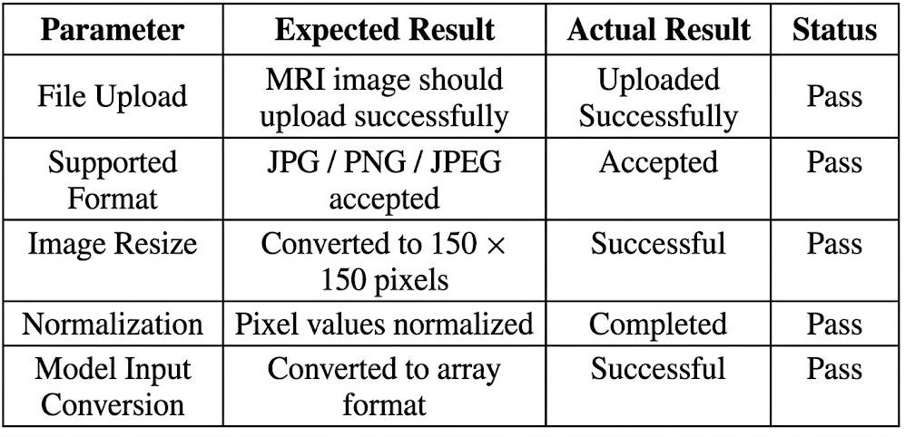

Table 7.2: Prediction Test 1 – Tumour MRI Image
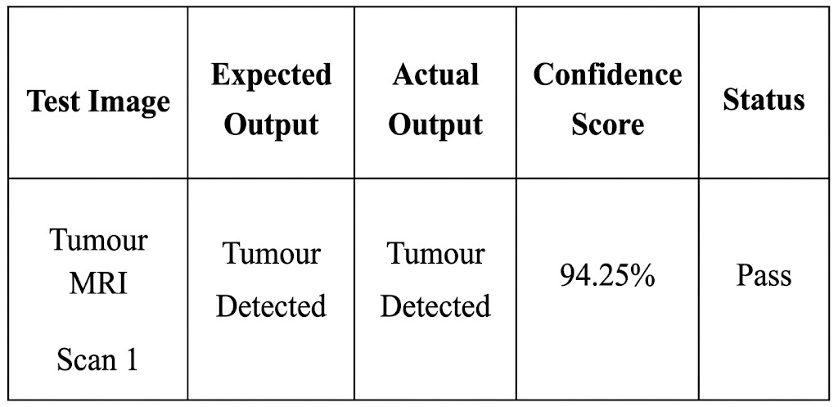

Table 7.3: Prediction Test 2 – Non-Tumour MRI Image
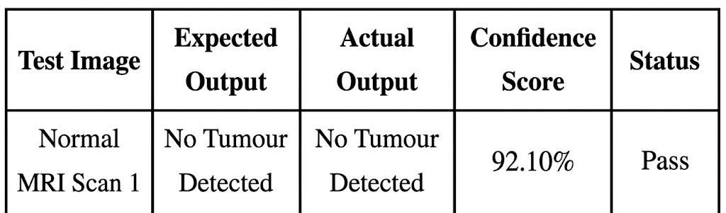

Table 7.4: Prediction Test 3 – Tumour MRI Image
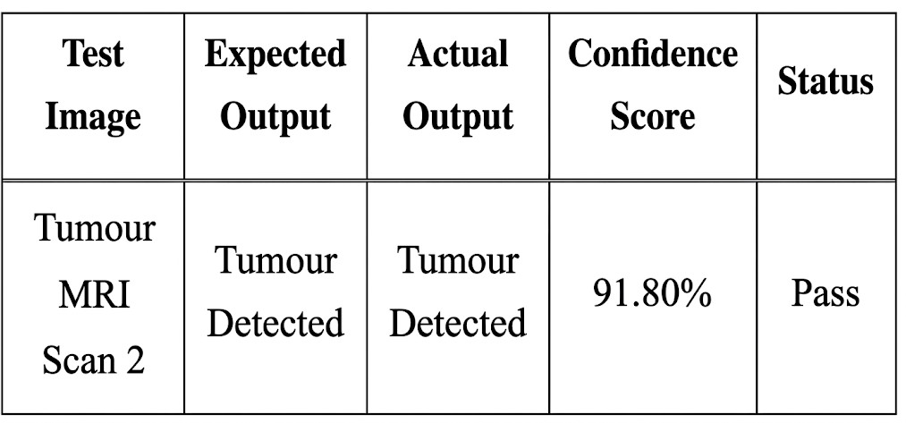

Table 7.5: Prediction Test 4 – Non-Tumour MRI Image
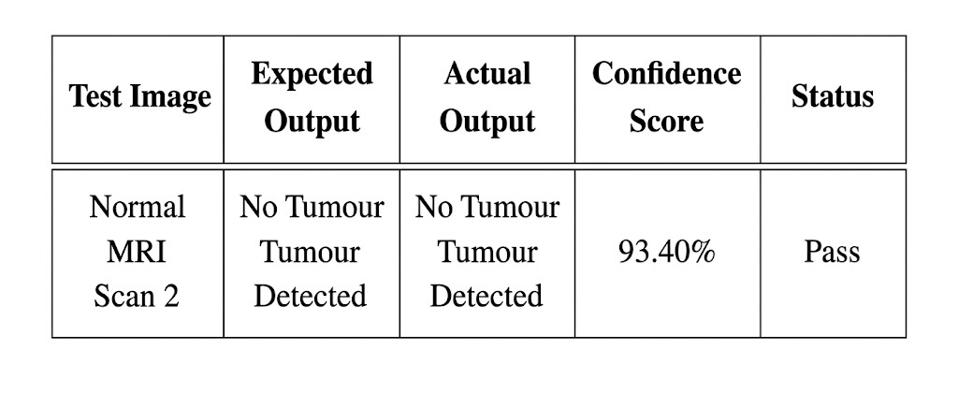

SCREENSHOTS

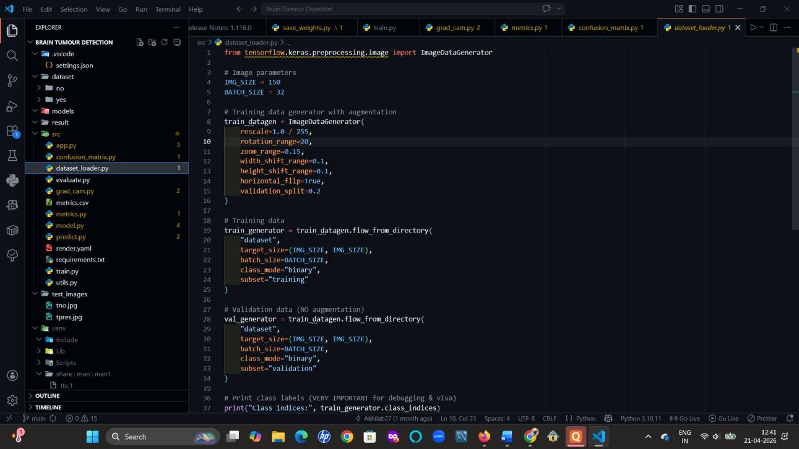
Fig 7.3(a) VS Code

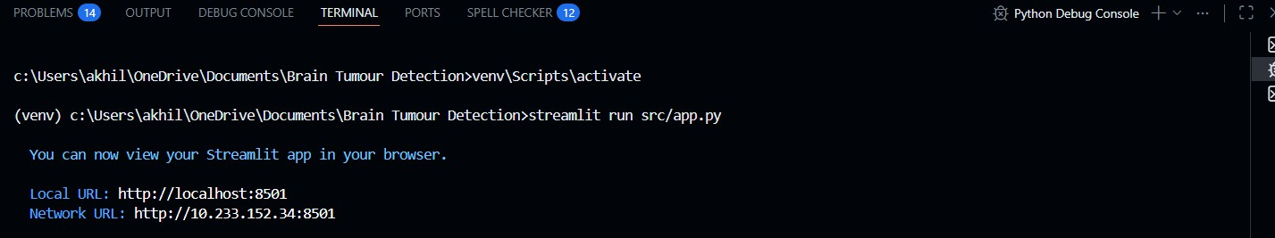

Fig 7.3(b) Snapshot of link to the website

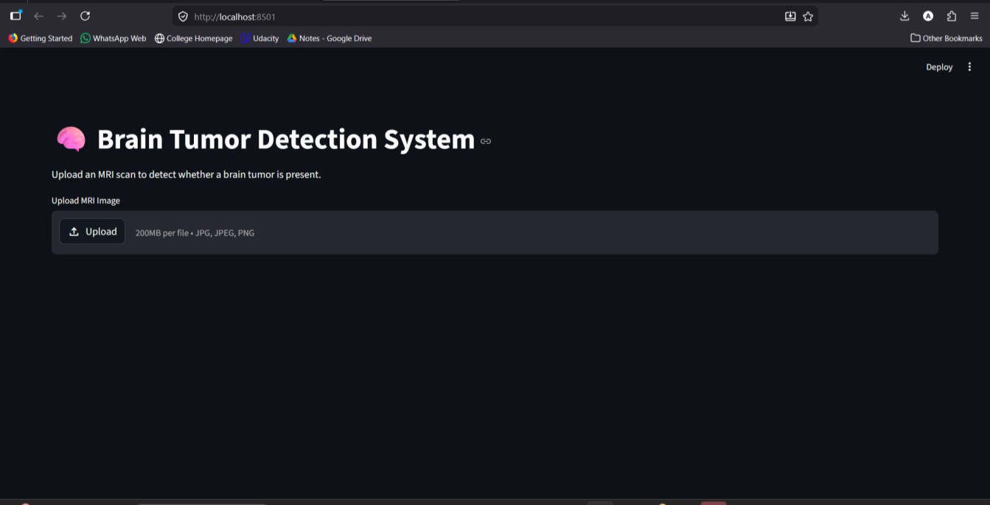
Fig 7.3(c) URL Enter page
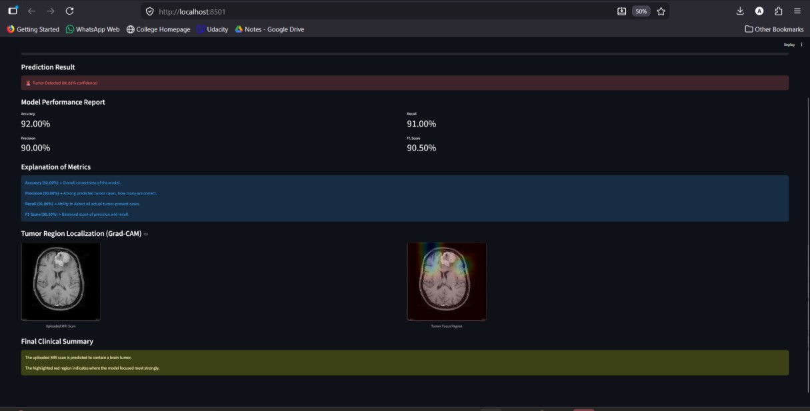

Fig 7.3(d) Output Snapshot 1

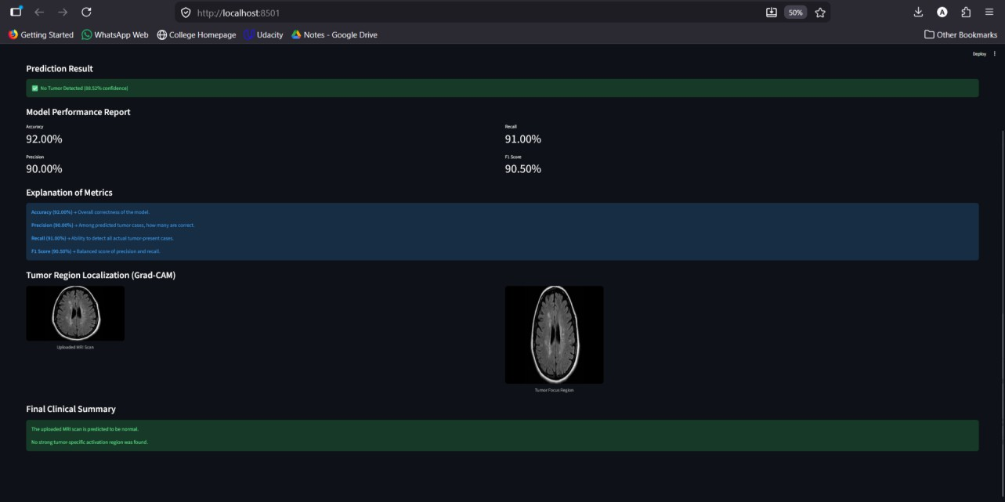

Fig 7.3(e) Output snapshot 2

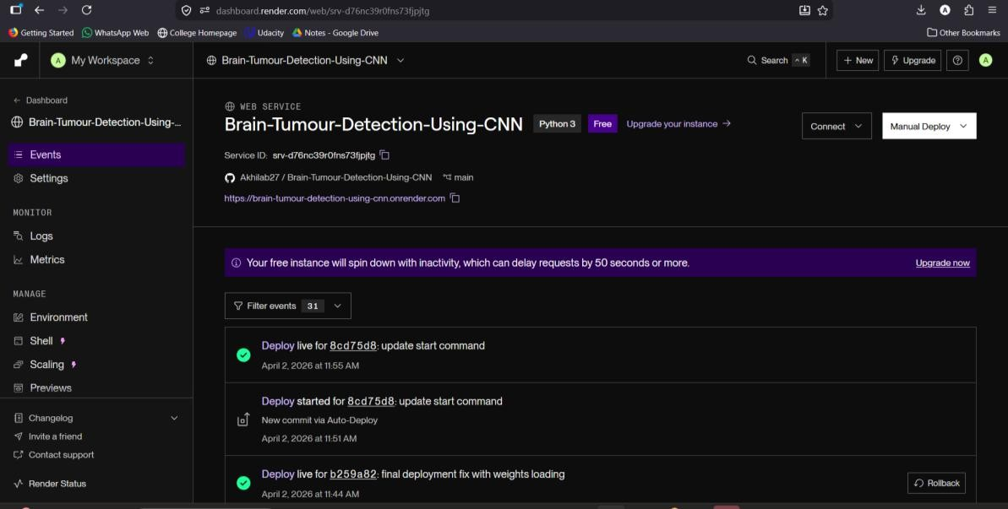
Fig 7.4(f)

CONCLUSION AND FUTURE ENHANCEMENT

CONCLUSION AND FUTURE ENHANCEMENT

CONCLUSION

The proposed Brain Tumour Detection System is developed to provide an efficient and automated method for identifying brain tumours from MRI images using deep learning techniques. The system uses the MobileNetV2 model with transfer learning to classify MRI scans into tumour and non-tumour categories with high accuracy. Image preprocessing techniques such as resizing, normalization, and array conversion are applied to improve the quality of input data before prediction. The trained model achieved good performance with satisfactory accuracy, precision, recall, and F1-score values.

A Streamlit-based web interface is developed to make the system user-friendly and interactive. Users can upload MRI images and instantly obtain prediction results along with confidence score and Grad-CAM visualization for better interpretability. The testing results show that the proposed system performs reliably for different MRI images and provides consistent outputs. The use of Grad-CAM improves transparency by highlighting suspicious tumour regions..

FUTURE ENHANCEMENT

The proposed Brain Tumour Detection System can be enhanced in future by using a larger and more diverse MRI image dataset to improve model accuracy and prediction performance. Multi-class classification can also be implemented to detect different types of brain tumours such as glioma, meningioma, and pituitary tumours instead of only tumour and non-tumour classes.

The system can be deployed on cloud platforms and developed as a mobile application for easier access. Advanced deep learning models such as EfficientNet, ResNet, and Vision Transformers can be used for better results. Additional features such as patient report storage, hospital integration, and improved explainable AI techniques can make the system more practical and efficient.

REFERENCES

REFERENCES

- S. Deepak and P. M. Ameer, "Brain Tumor Classification Using Deep CNN Features via Transfer Learning," Computers in Biology and Medicine, vol. 111, 2019, pp. 103345.
- N. Abiwinanda, M. Hanif, S. T. Hesaputra, A. Handayani and T. R. Mengko, "Brain Tumor Classification Using Convolutional Neural Network," World Congress on Medical Physics and Biomedical Engineering, 2018, pp. 183-189.
- M. Havaei, A. Davy, D. Warde-Farley et al., "Brain Tumor Segmentation with Deep Neural Networks," Medical Image Analysis, vol. 35, 2017, pp. 18-31.
- S. Pereira, A. Pinto, V. Alves and C. A. Silva, "Brain Tumor Segmentation Using Convolutional Neural Networks in MRI Images," IEEE Transactions on Medical Imaging, vol. 35, no. 5, 2016, pp. 1240-1251.
- K. Muhammad, S. Khan, J. Del Ser and V. H. C. de Albuquerque, "Deep Learning for Multigrade Brain Tumor Classification in Smart Healthcare Systems," IEEE Access, vol. 8, 2020, pp. 200080-200091.
- M. Sajjad, S. Khan, K. Muhammad et al., "Multi-grade Brain Tumor Classification Using Deep CNN with Extensive Data Augmentation," Journal of Computational Science, vol. 30, 2019, pp. 174-182.
- O. Russakovsky et al., "ImageNet Large Scale Visual Recognition Challenge,"
International Journal of Computer Vision, vol. 115, no. 3, 2015, pp. 211-252.
- A. Krizhevsky, I. Sutskever and G. E. Hinton, "ImageNet Classification with Deep Convolutional Neural Networks," Advances in Neural Information Processing Systems, 2012,
pp. 1097-1105.
- M. Sandler, A. Howard, M. Zhu, A. Zhmoginov and L. C. Chen, "MobileNetV2: Inverted Residuals and Linear Bottlenecks," IEEE Conference on Computer Vision and Pattern Recognition (CVPR), 2018, pp. 4510-4520.
- F. Chollet, "Xception: Deep Learning with Depthwise Separable Convolutions," IEEE Conference on Computer Vision and Pattern Recognition, 2017, pp. 1251-1258.

- K. He, X. Zhang, S. Ren and J. Sun, "Deep Residual Learning for Image Recognition,"
IEEE Conference on Computer Vision and Pattern Recognition, 2016, pp. 770-778.
- J. Selvaraju, M. Cogswell, A. Das et al., "Grad-CAM: Visual Explanations from Deep Networks via Gradient-based Localization," IEEE International Conference on Computer Vision, 2017, pp. 618-626.
- I. Goodfellow, Y. Bengio and A. Courville, Deep Learning. MIT Press, 2016.
- A. Géron, Hands-On Machine Learning with Scikit-Learn, Keras, and TensorFlow.
O’Reilly Media, 2019.
- TensorFlow Documentation [online]. Available: https://www.tensorflow.org/
- Keras Documentation [online]. Available: https://keras.io/
- Streamlit Documentation [online]. Available: https://streamlit.io/
- OpenCV Documentation [online]. Available: https://opencv.org/
- NumPy Documentation [online]. Available: https://numpy.org/
- Scikit-learn Documentation [online]. Available: https://scikit-learn.org/

